Lion Pride
 |  |  |  | 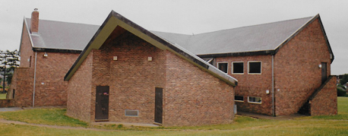
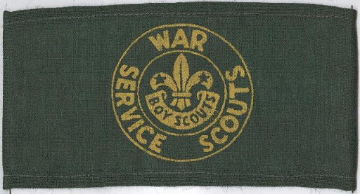 |  | 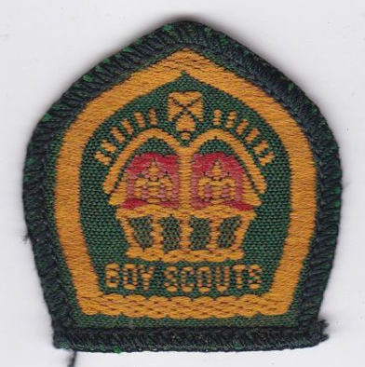
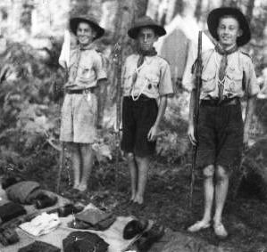 | 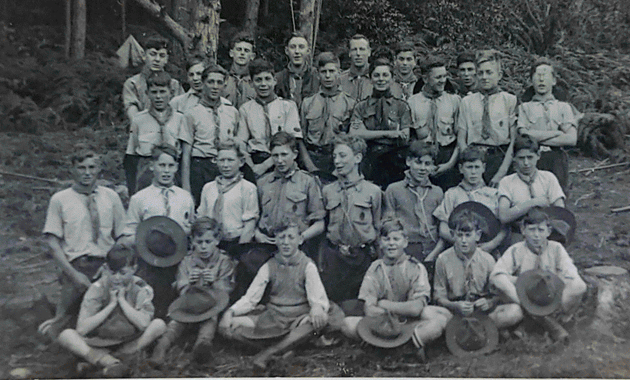
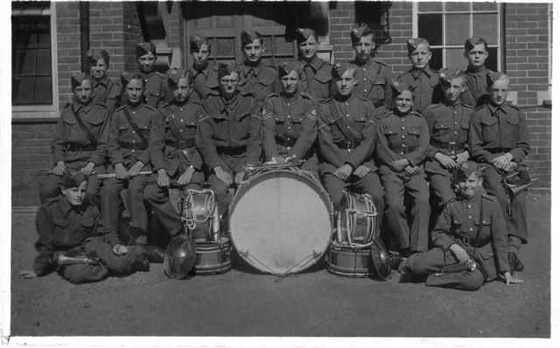
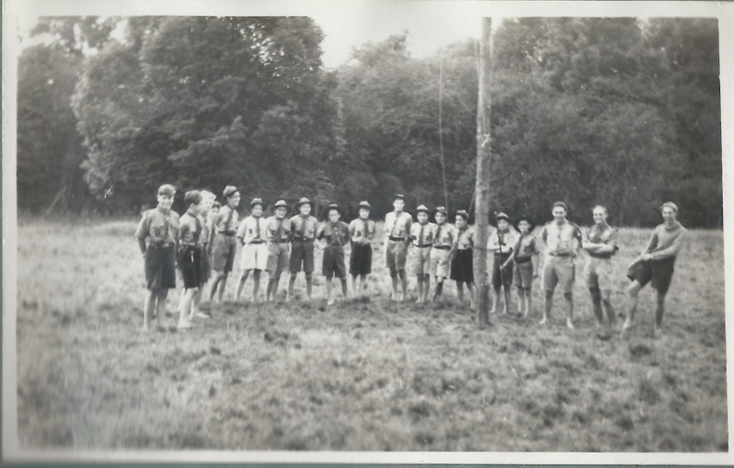 |  |  |  |  | 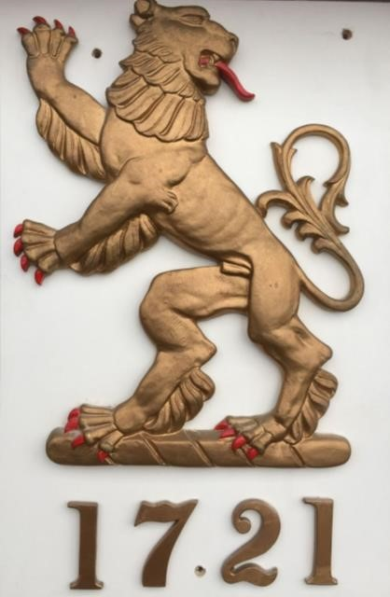
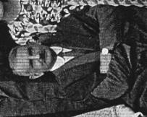 | 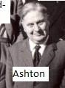 |  | 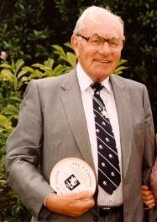 |  | 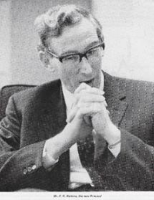

Chapter 12 Price’s Scout Troop
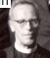  Lion Pride | Chapter 12 | 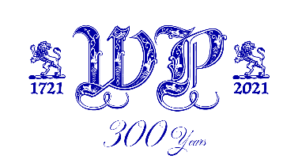
 | 9th Fareham (Price’s School) Scout Troop

In the midst of Wartime, inspired guidance and great personal qualities brought the most unlikely of groups into existence, introducing boys to a wide range of experiences and values, loyalty and service that were the hallmark of an excellent leader. An 11 year spell of opportunities which, aside from the activity Reports written, brought forth no lasting legacy to the School. A matter of regret. Let this Chapter make good some of that deficiency.

Requests to the Hampshire Scout H.Q. ands to the National H.Q. have brought forth no documentary evidence of this group, the story of which is reproduced here as appeared in the Lion magazines, and with a few photos that have arrived since.

Principal Contents

Lion Magazine entries | 1941 Dec | All Reports written by  The Revd. E. Melville (Ted) Royds Jones
Lion Magazine entries | 1942 July
Lion Magazine entries | 1942 Dec
Lion Magazine entries | 1943, July
Lion Magazine entries | 1943, Dec
Lion Magazine entries | 1944, July
Lion Magazine entries | 1945, Mar
Lion Magazine entries | 1945, July
Lion Magazine entries | 1945, Dec
Lion Magazine entries | 1946, July
Lion Magazine entries | 1946, Dec
Beaudesert International Scout Camp | 1946, Dec
Lion Magazine entries | 1947, Mar
Lion Magazine entries | 1947, July
Lion Magazine entries | 1947, Dec
Lion Magazine entries | 1948, Mar
Lion Magazine entries | 1948, July
Lion Magazine entries | 1948, Dec
Lion Magazine entries | 1949, May
Lion Magazine entries | 1949, Aug
Lion Magazine entries | 1950, Jan
Lion Magazine entries | 1950, Aug
Lion Magazine entries | 1951, Aug
Lion Magazine entries | 1952, Jan
Lion Magazine entries | 1952, May
Camp + photo | 1941/42 | Eric Butcher
Scout Camp Locations |  | David Goldring
Edition of “The Ninth” | 1944, Oct | c/o Victor Hughes
Review |  | David Goldring
Photos |  | c/o Peter Phelan
Link to “Adventure in North Wales”
Queen Scout John Rousell |  | John Rousell
Developmental stages of the Troop |  | David Goldring
An Overview |  | David Goldring

1941, December
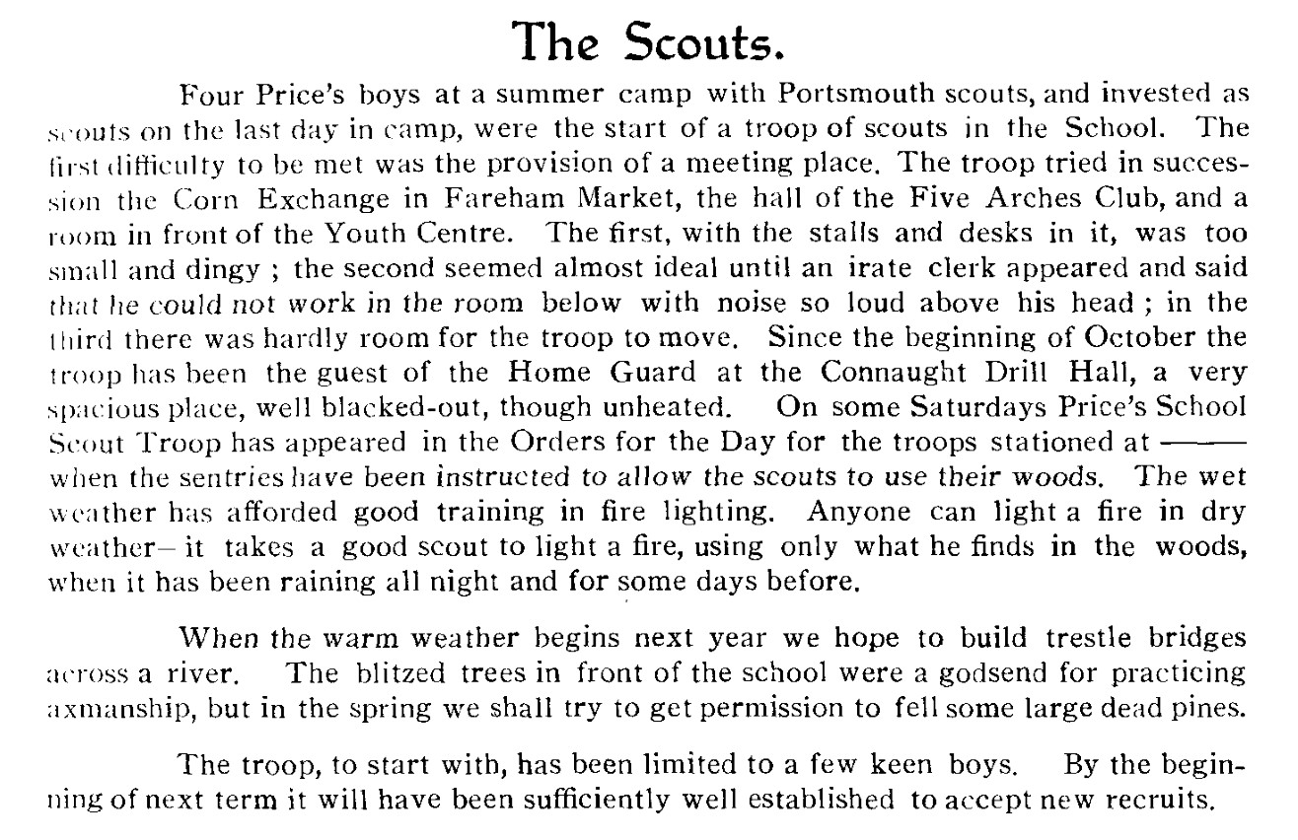

It seemed like a good idea at the time!

Eric Butcher writes of Scout Camp with "Wick"
I found this picture of the Prices Scout Troop with me and John Coghlan, I think in either 1941/42. We are both in the second row up. As seen, I am the second in from the right, and John is the second in from the left . The camp was at Rogate. We camped in ridge tents, one of which can be seen in the background. The Scout Master was the Rev Royds Jones otherwise known as “The Wick” (nobody knows where his nick name came from). I know the boy next to me is John Coghlan who was a close friend but cannot identify anyone else. I remember parents came to visit half was though the week to see what we were doing, with a number of cakes brought to help us survive. Best Wishes Eric Butcher ( dates at Prices 1941 to 1946)

1942, July
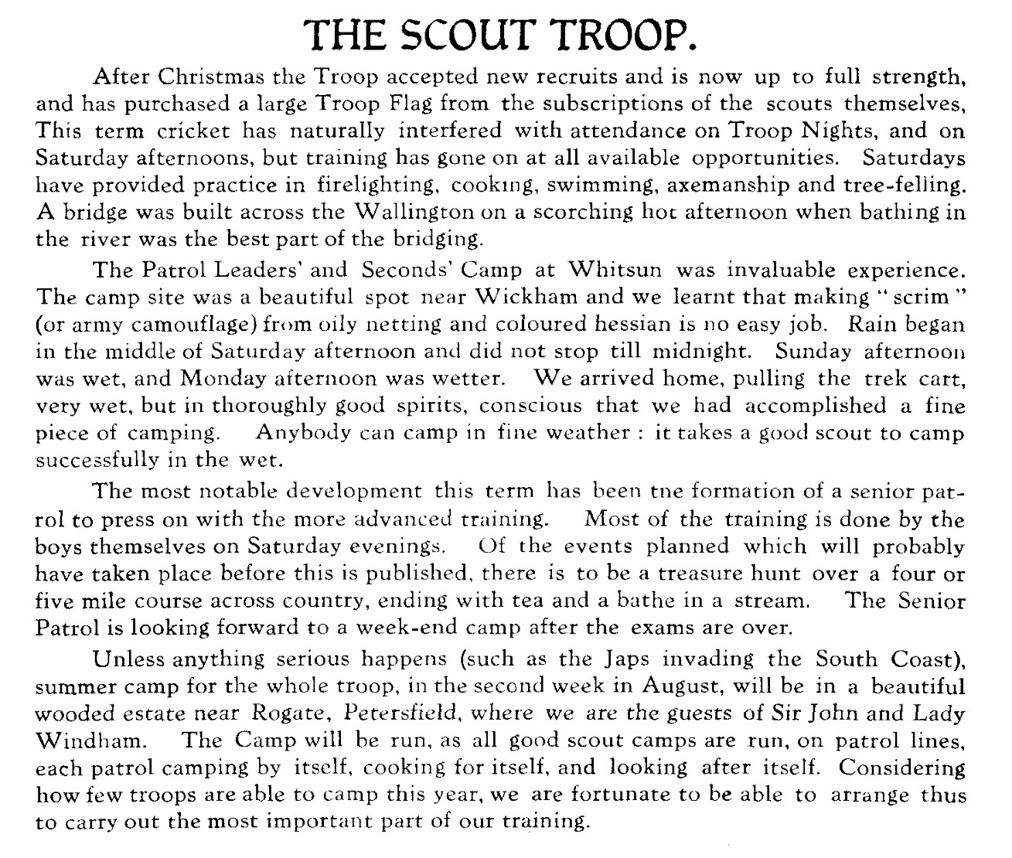

Good Camp site. Pity about the weather!

1942, December
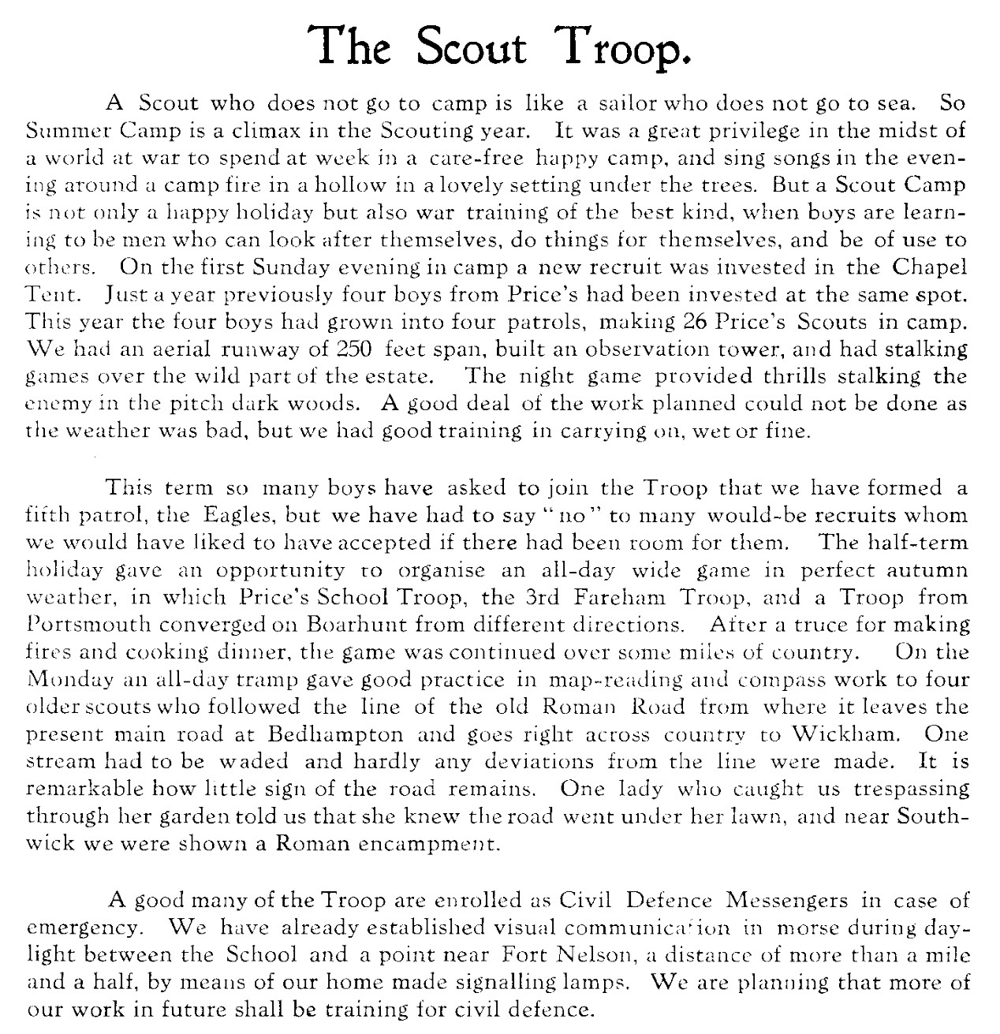

In the midst of a world at war ….. a carefree and happy camp …. sing songs in the evening around a camp fire in a hollow in a lovely setting beneath some trees. Boys are learning to be men who can look after themselves …. and be of use to others. 26 Price’s boys in 4 Patrols.

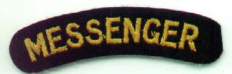

1943, July
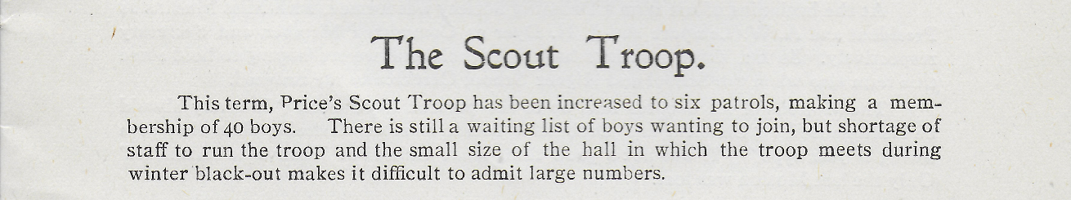
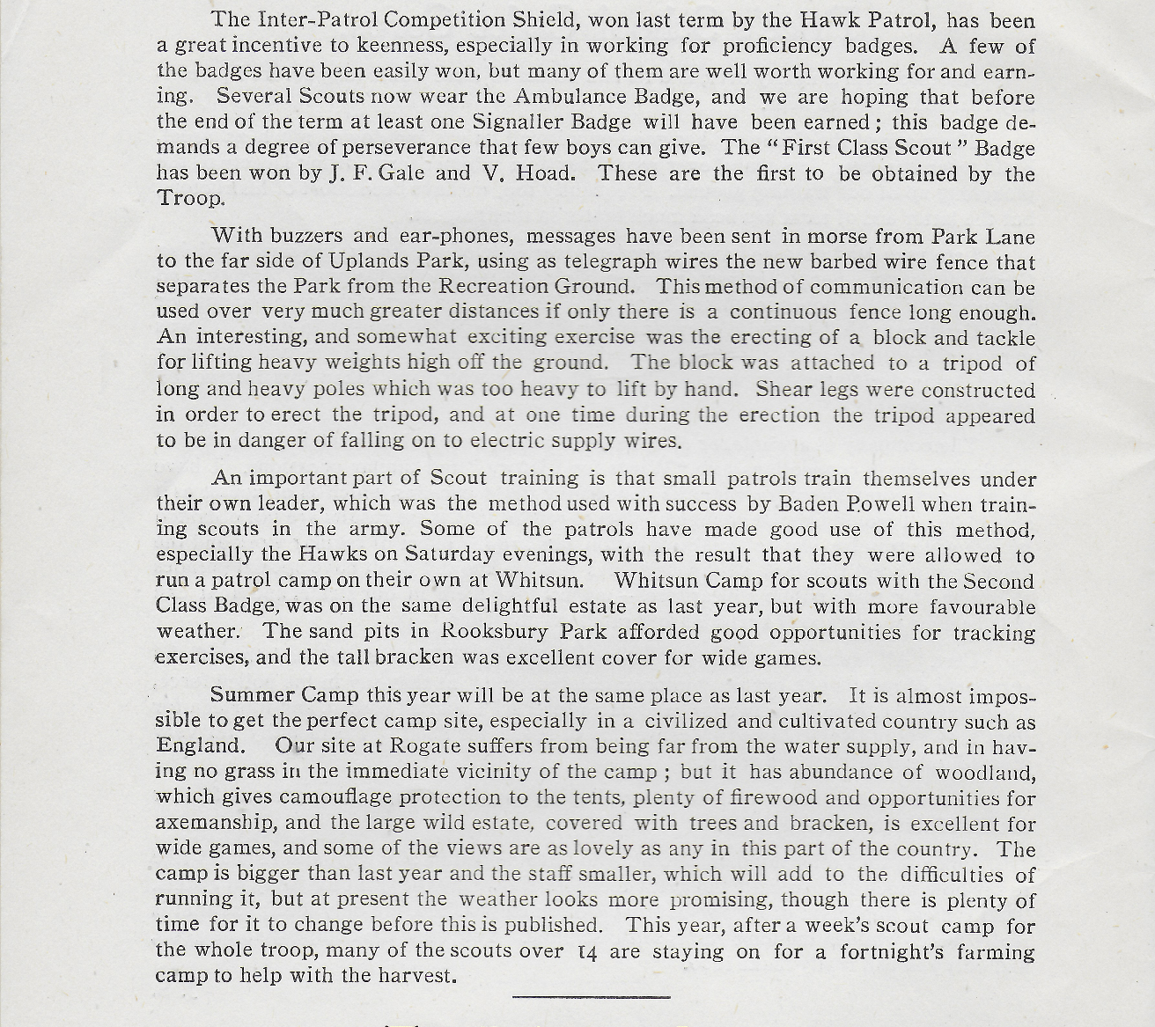

1943, December
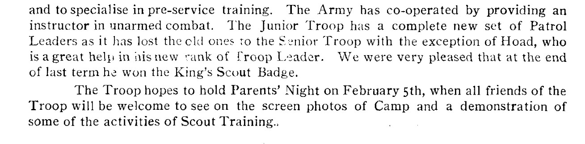
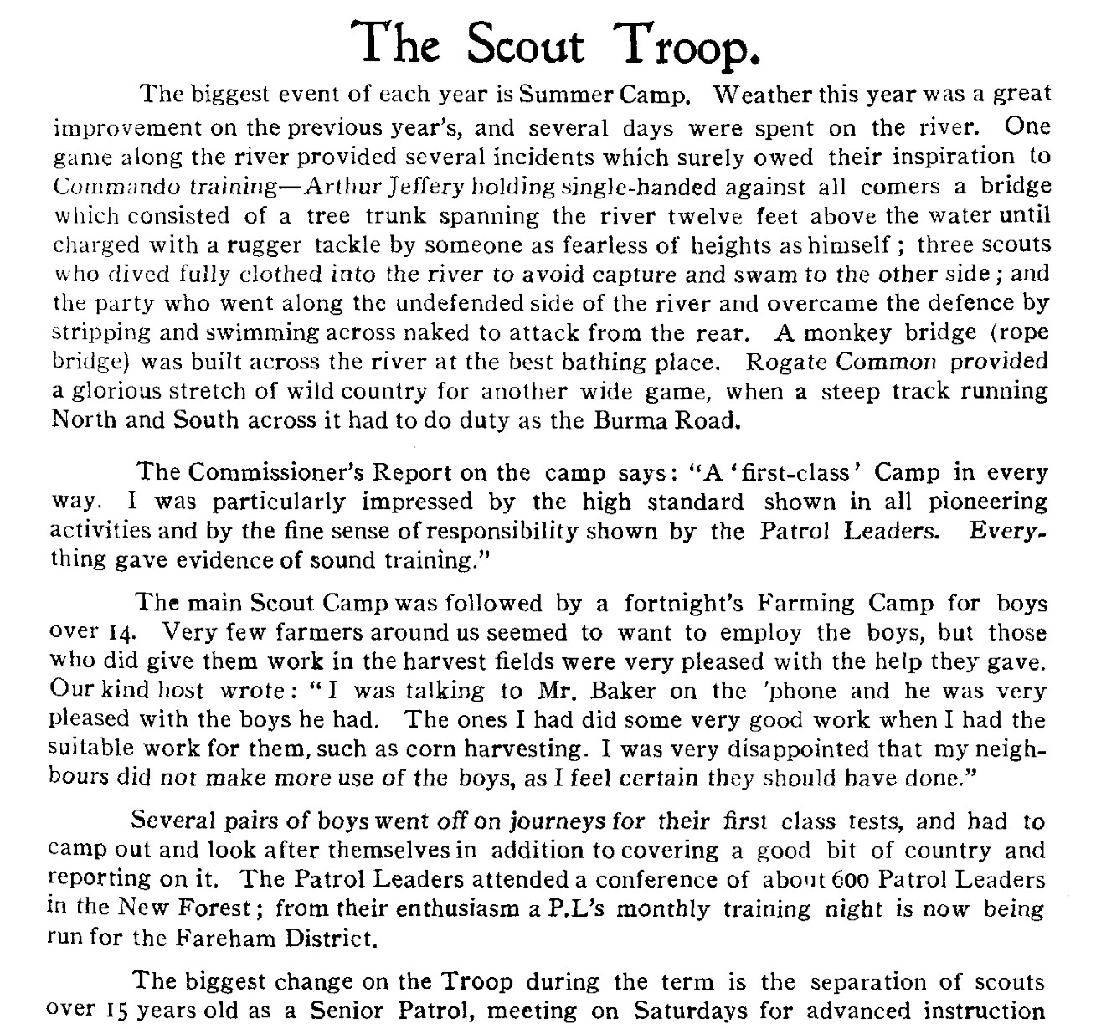

“Everything gave evidence of sound training”. An expansion of Scout activities with training for older boys, with achievement acknowledged.

1944, July
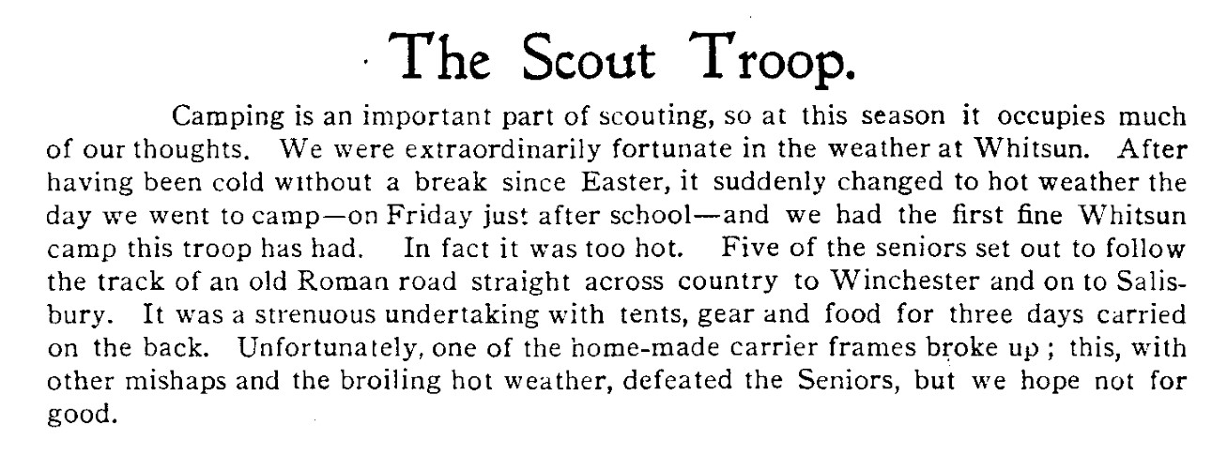
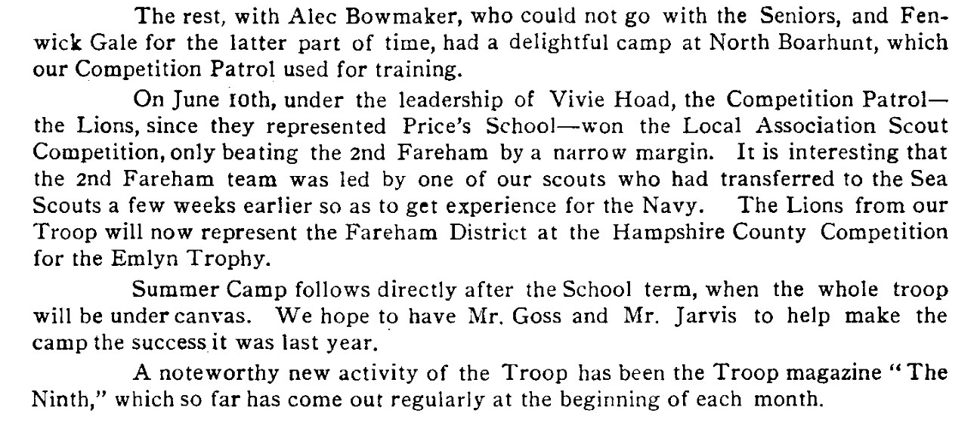

The Troop magazine referred-to has been a hitherto (May 2020) unknown aspect of Troop activity. From the last comment in the Report above of the 1944 Camp, it seems that it might have started in about Easter time, 1944.

Right out of the blue arrived the copy of issue No.5, sent to us by Victor Hughes. The full magazine appears at the end of this Chapter and is a remarkable product, for the detail it includes of the minutiae of the workings of a Scout Camp. It is a testimony to the “keenness” of the compiler, which seems to have been just a single person, clearly fired-up with his Scouting passion.

1945, March
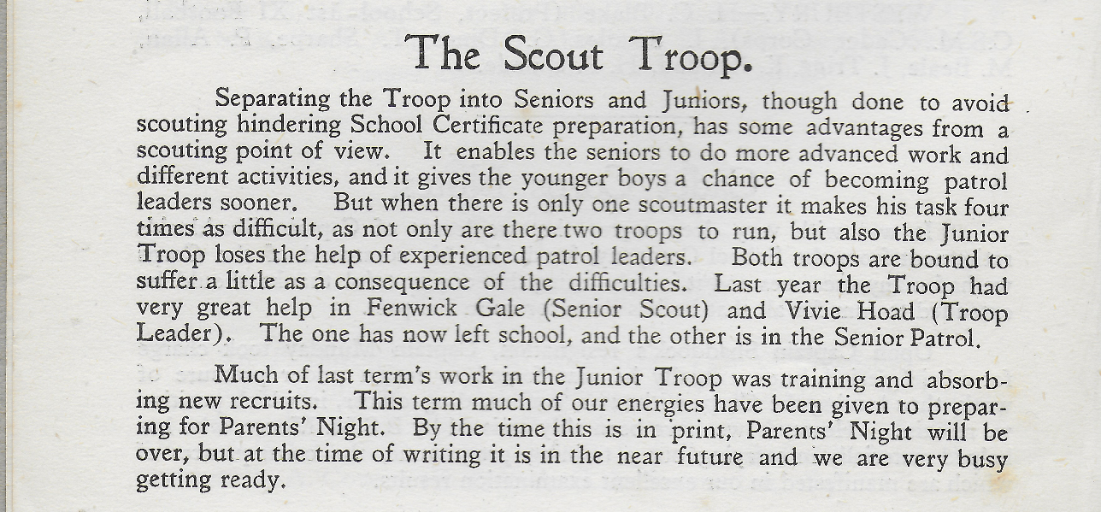
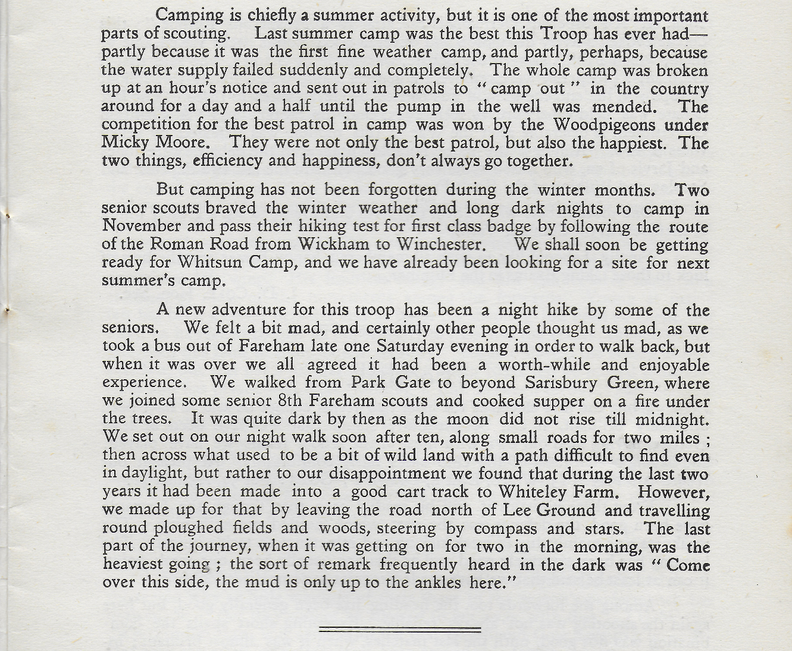

1945, July
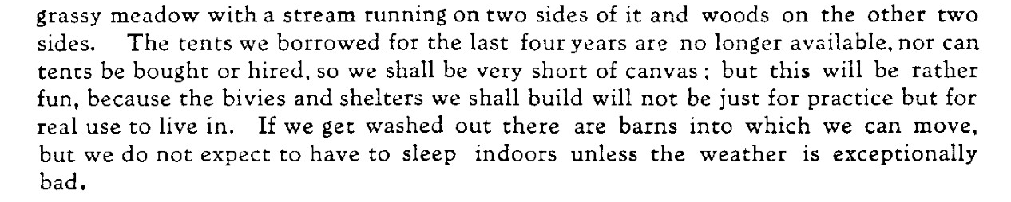
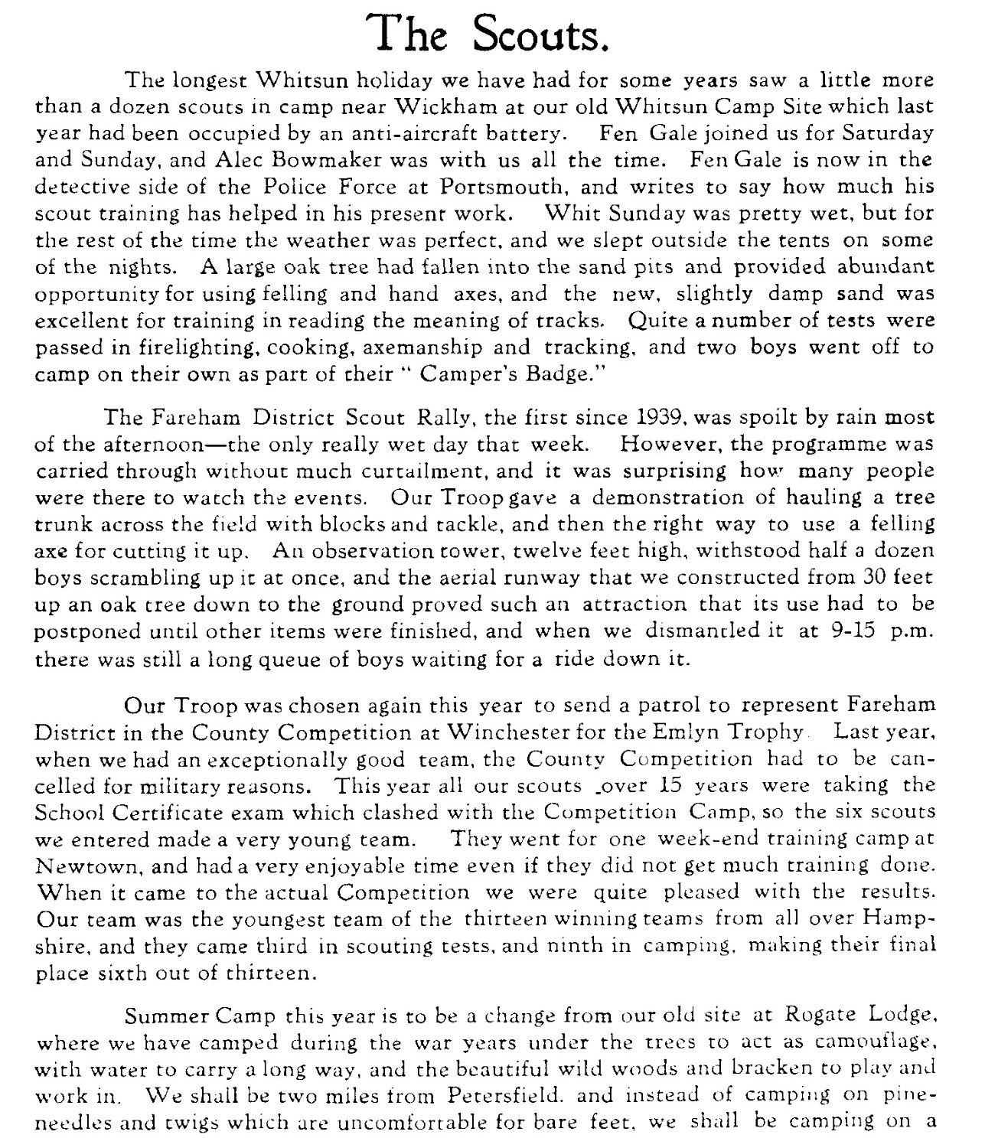

Two former pupils attending Camp to help: Alec Bowmaker and John Fenwick Gale.

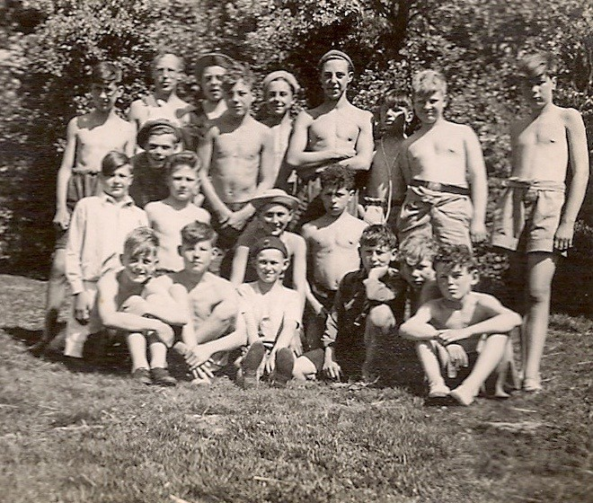
Picture c/o Peter Phelan. photograph was taken at Whitsun Camp in 1948 which was at Southwick House.

Back Row. Tony Sherwood, Royds, Gus Hughes, ? Unknown, “Titch” Stone, “Ticky”
Toyne? Unknown, Unknown, Peter Phelan.
Middle Row. Unknown, Brian Byng (wearing beret), David Stoneham? Unknown, Jennings?. Front Row (sitting). Roger Dimmock, Colin Nicholson, Neil Densham, Unknown, Unknown,
Unknown

1945, December
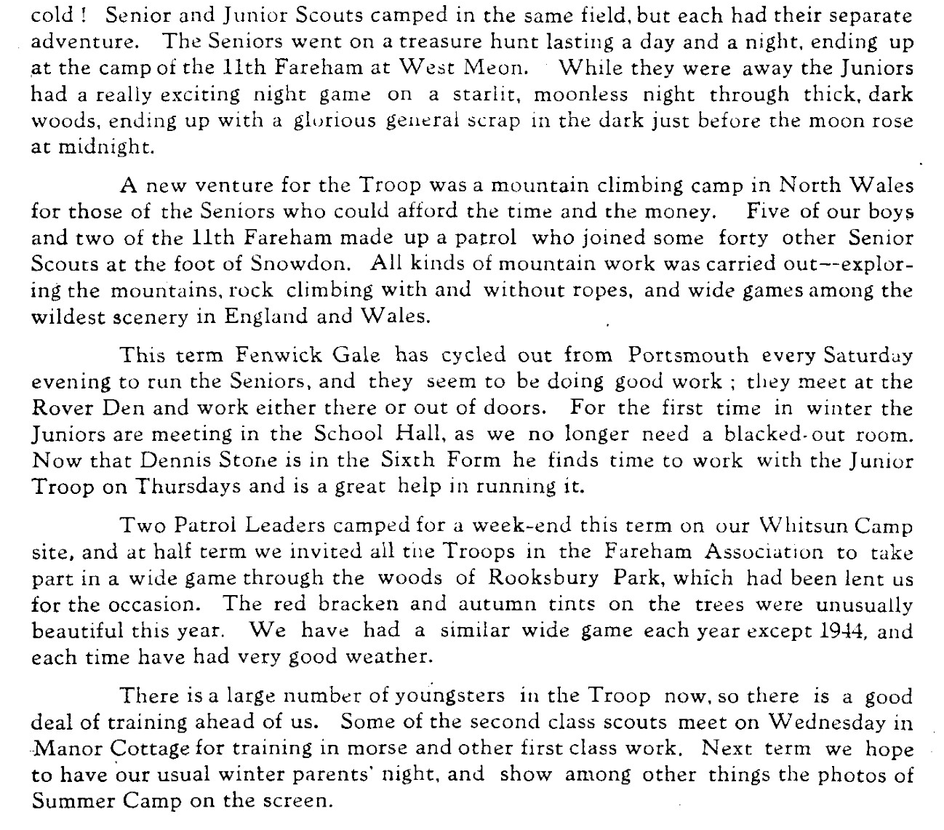
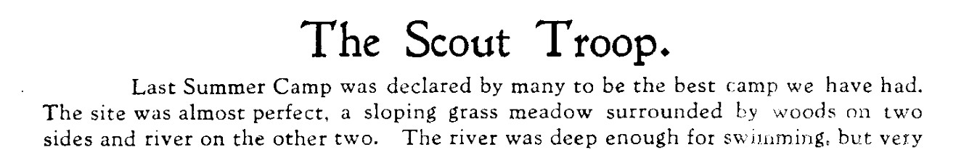

Continued involvement from past Pupil Fenwick Gale, working with Seniors.

1946, July
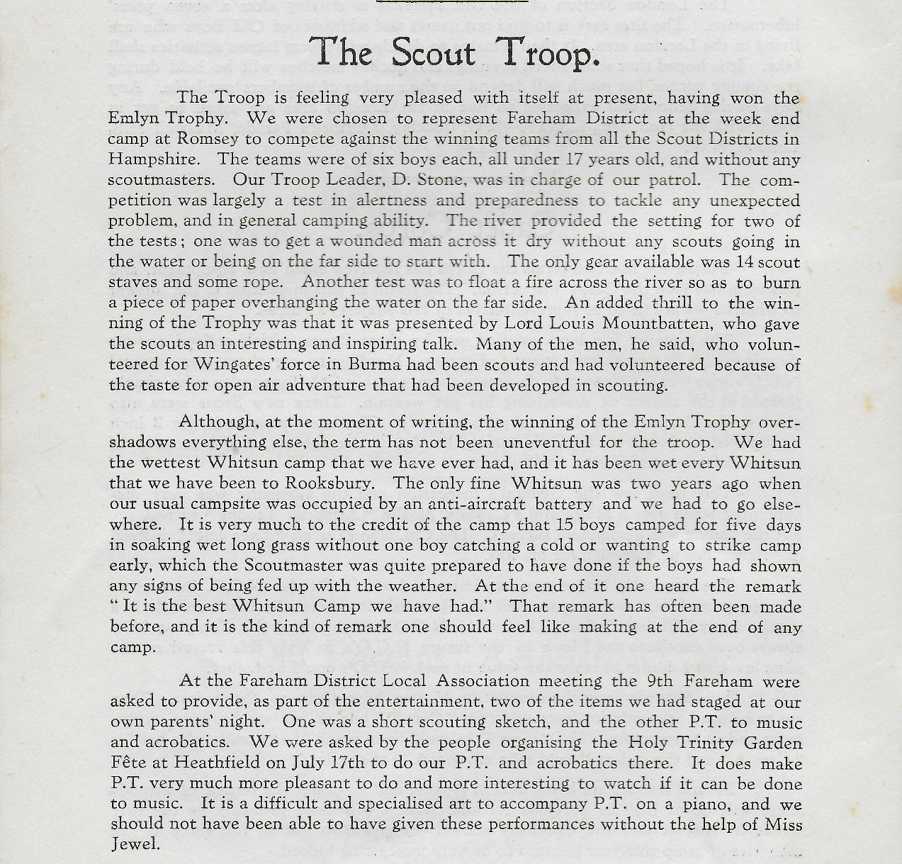
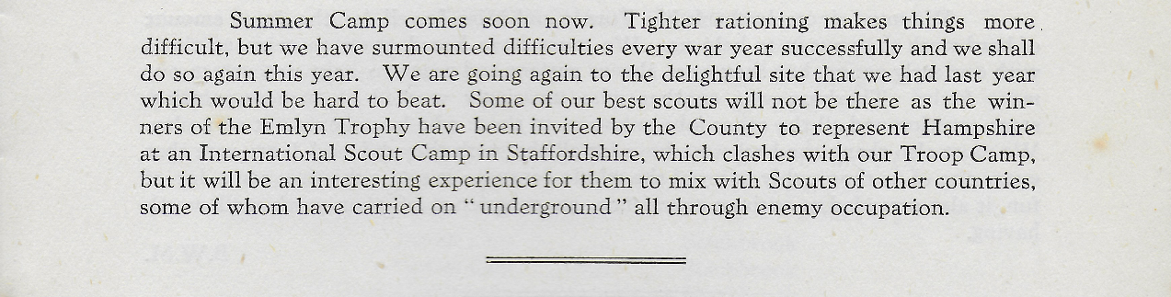

1946, December
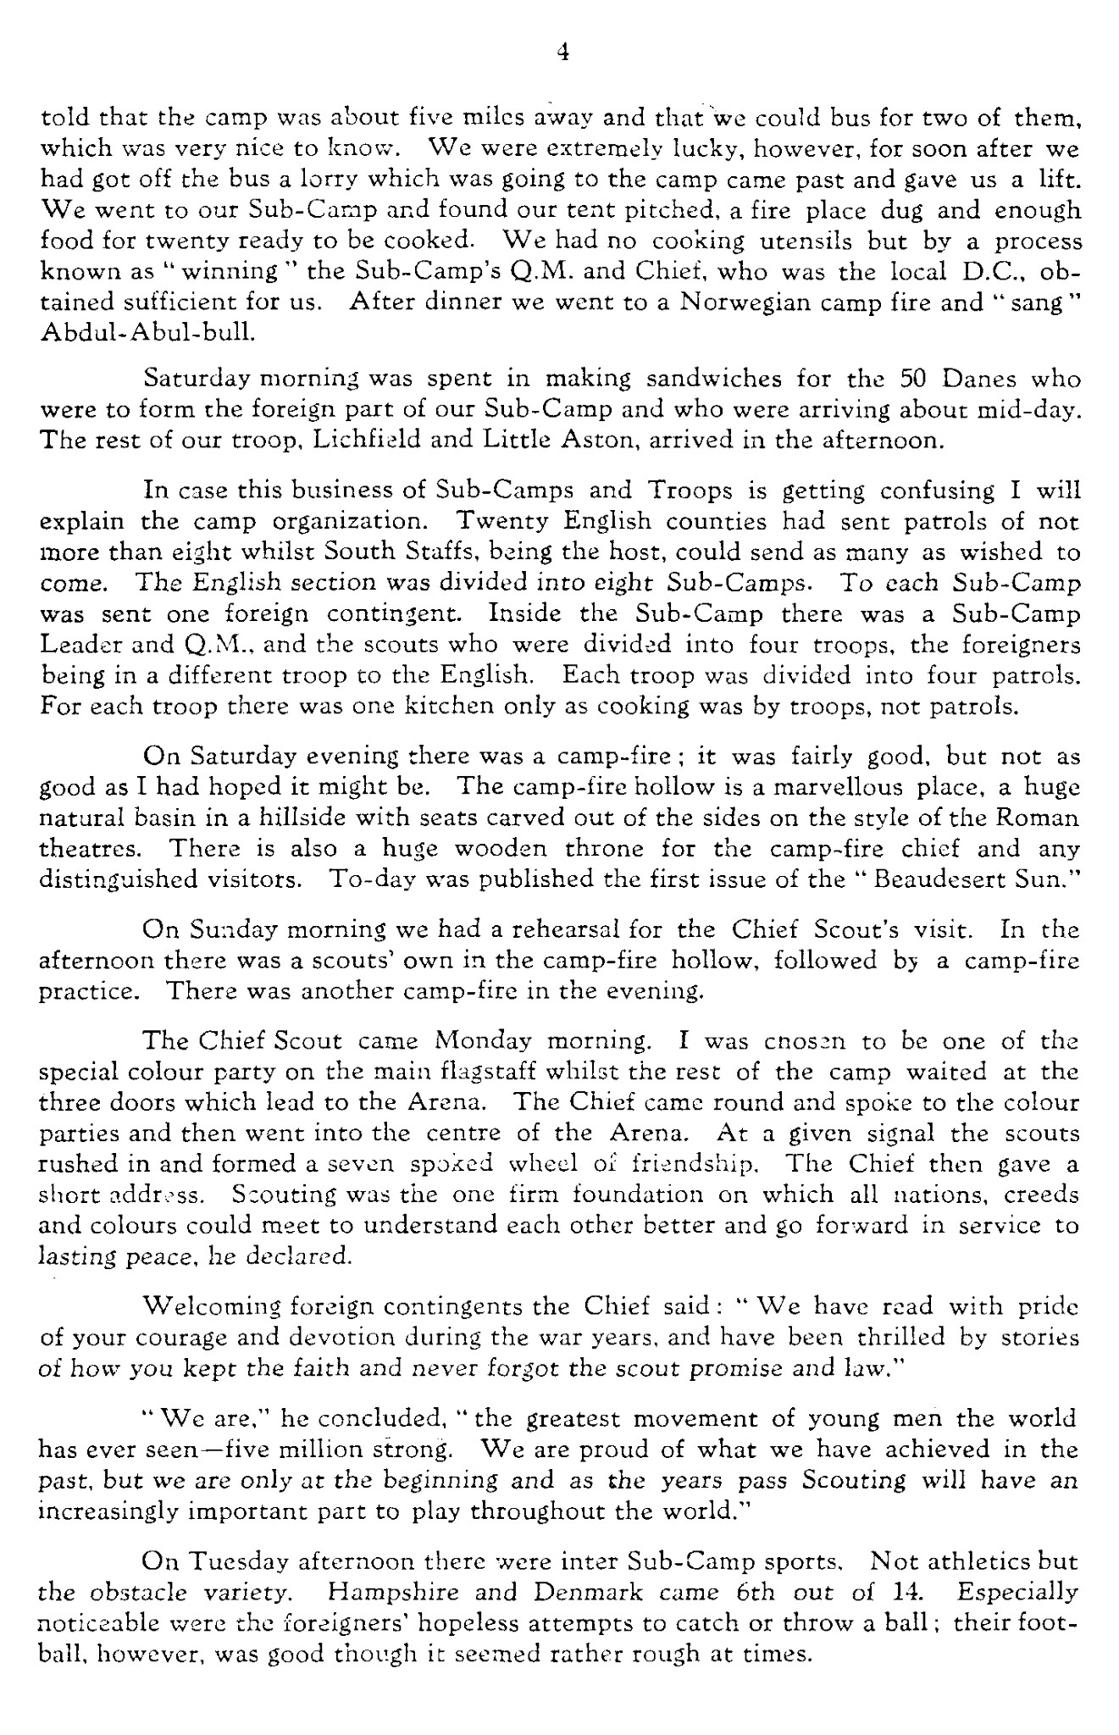
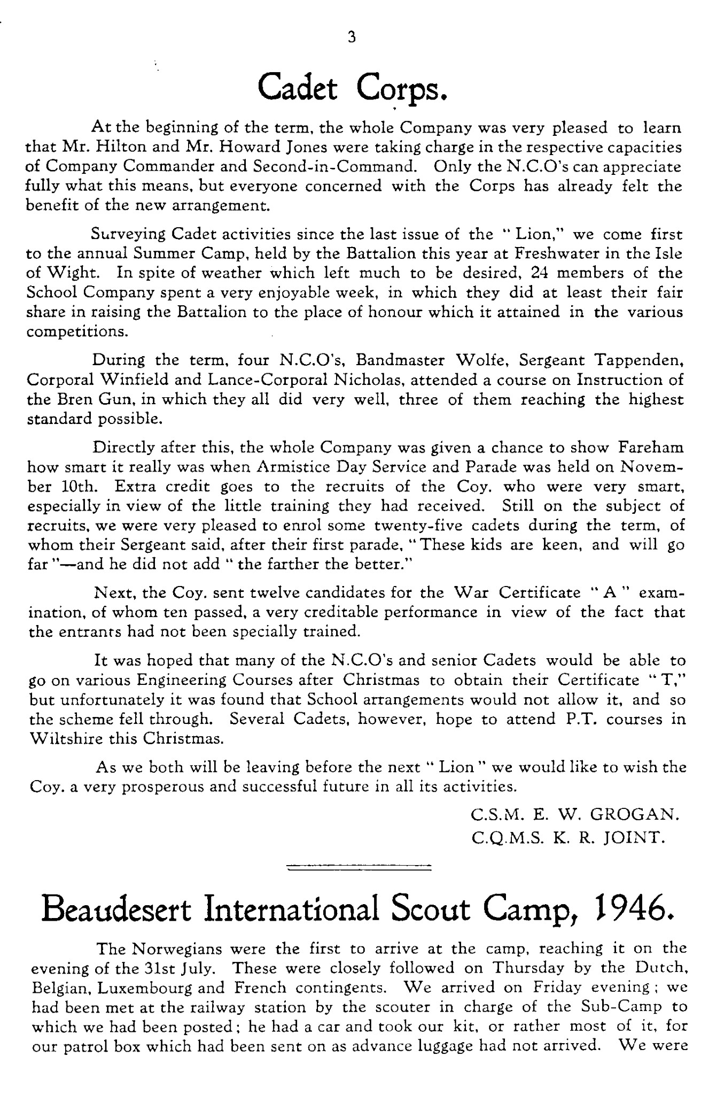

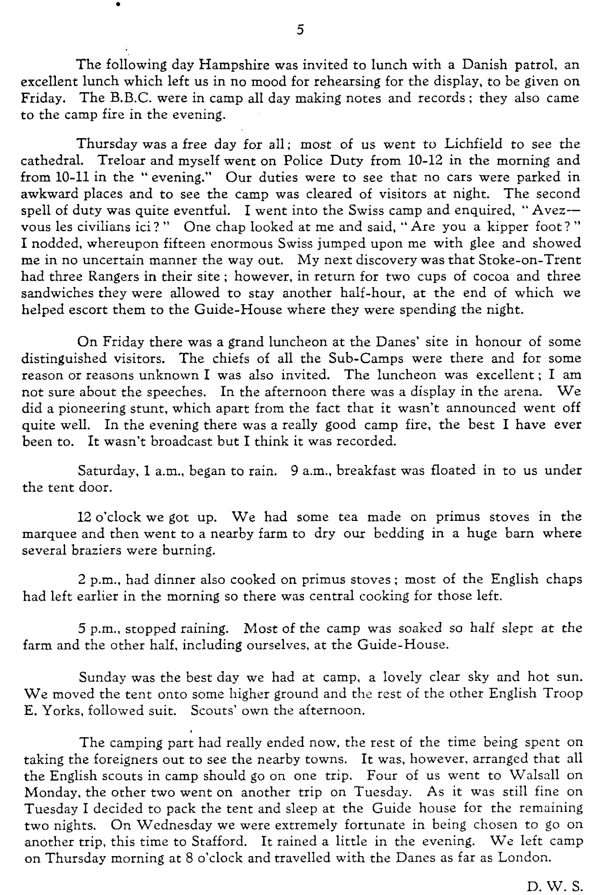
Continued

For many boys, this may well have been a first contact with foreigners.

1947, March
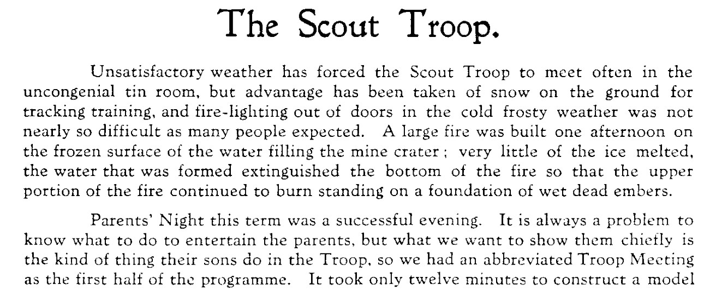
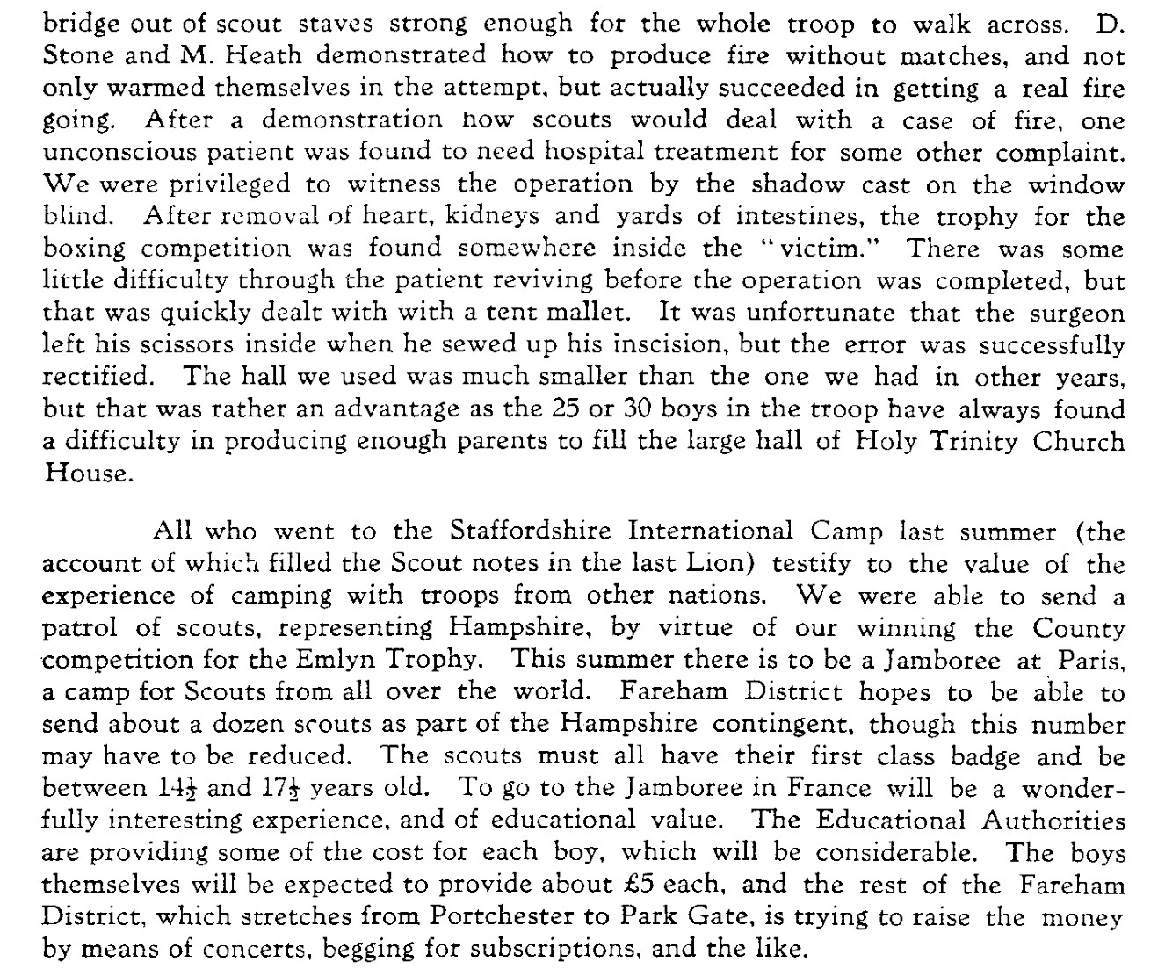

1947, July
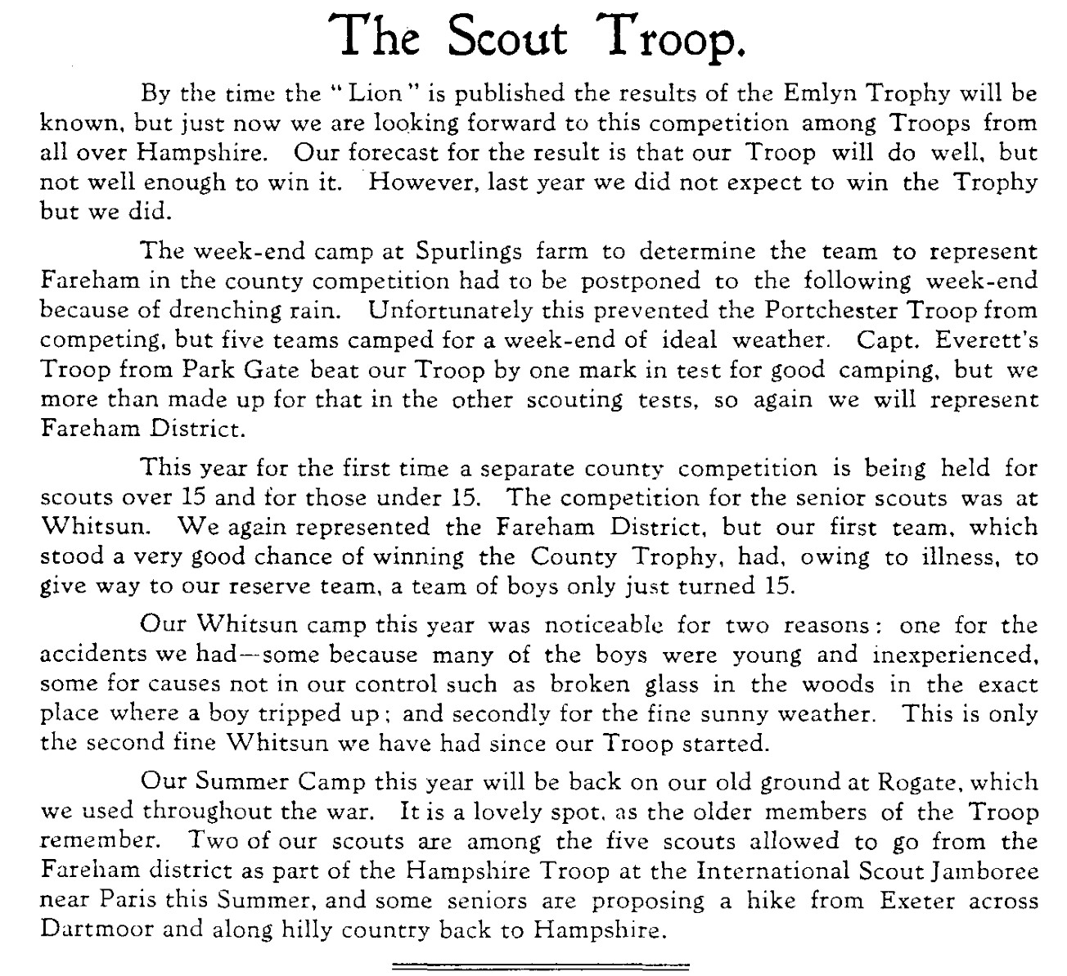

 | 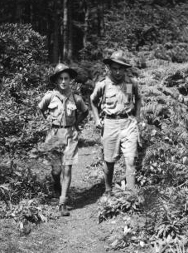
Scout camp 1947 - Inspection  L - R Michael Herbert, Tony Sherwood, John Farthing | Hiker's Badge 1947. L - R Michael Herbert, 'Pussy' Heath
On the back of the right hand photo, it states that this was at the start of an 18 mile hike over 2 days. The night was spent sleeping under a hedge!! Apologies to Mr Heath, as I cannot remember his first name and it says 'Pussy' on the photo.

1947 , December
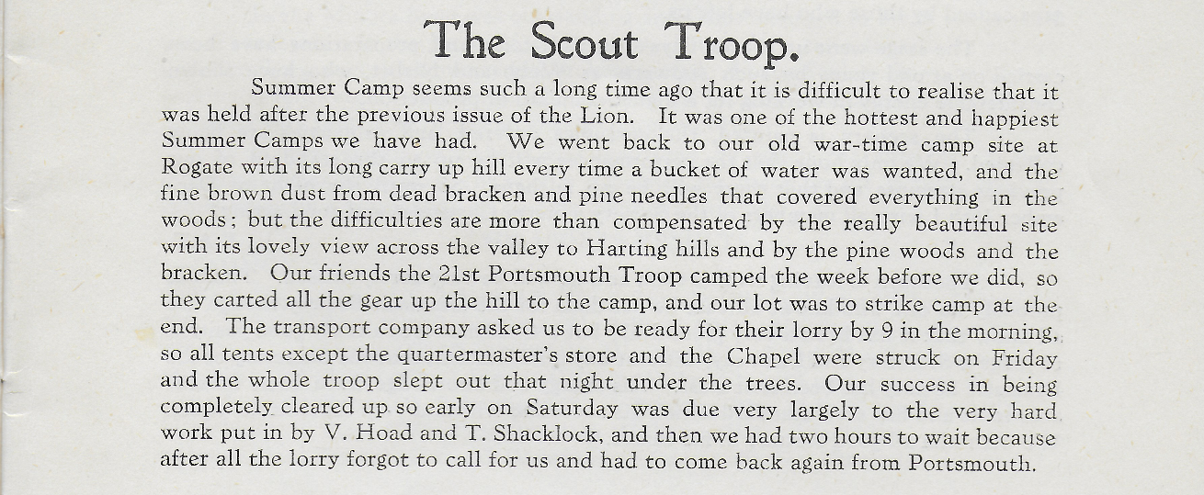
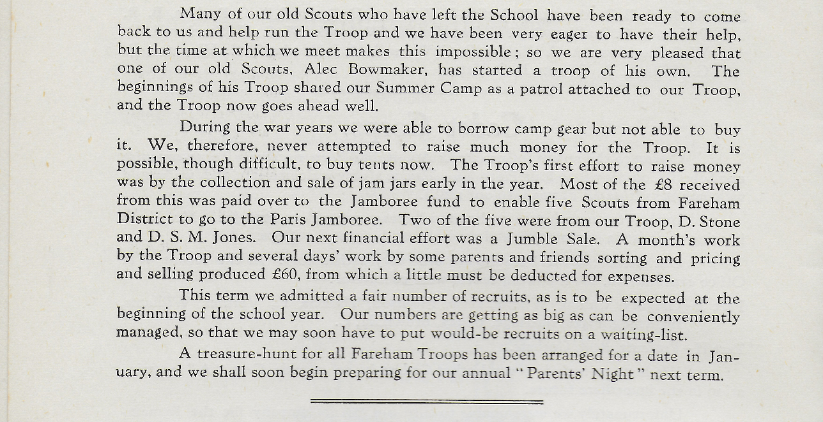

1948, March
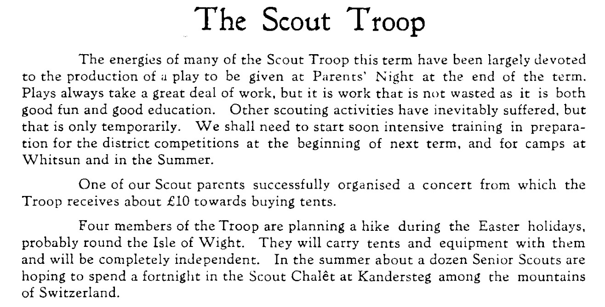

1948, July
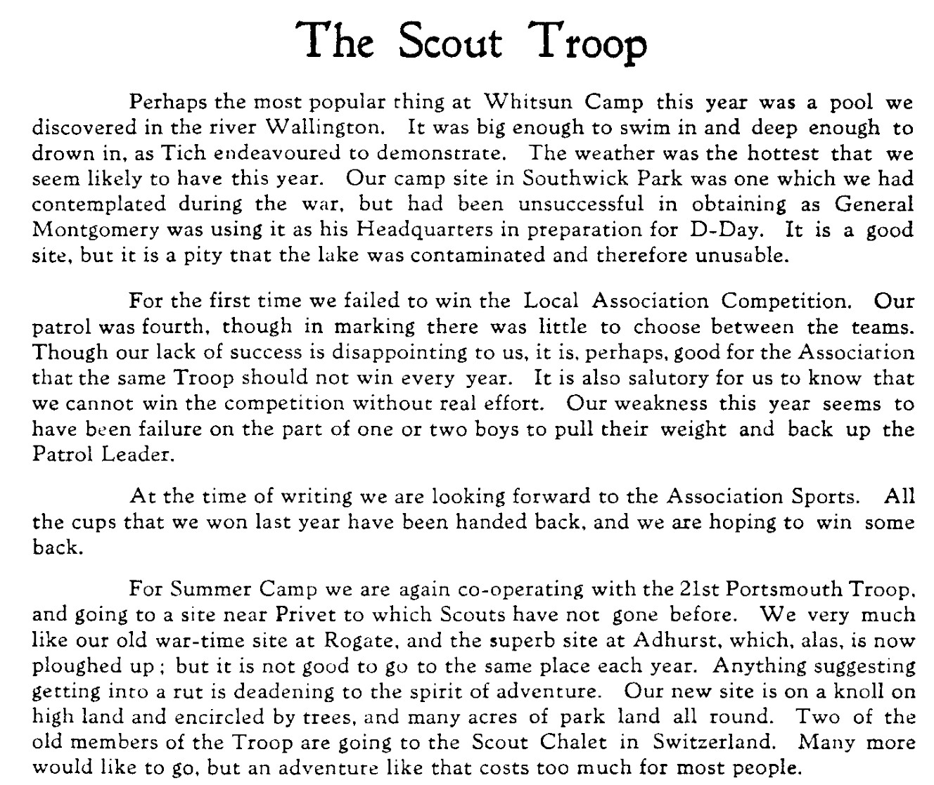

1948. December
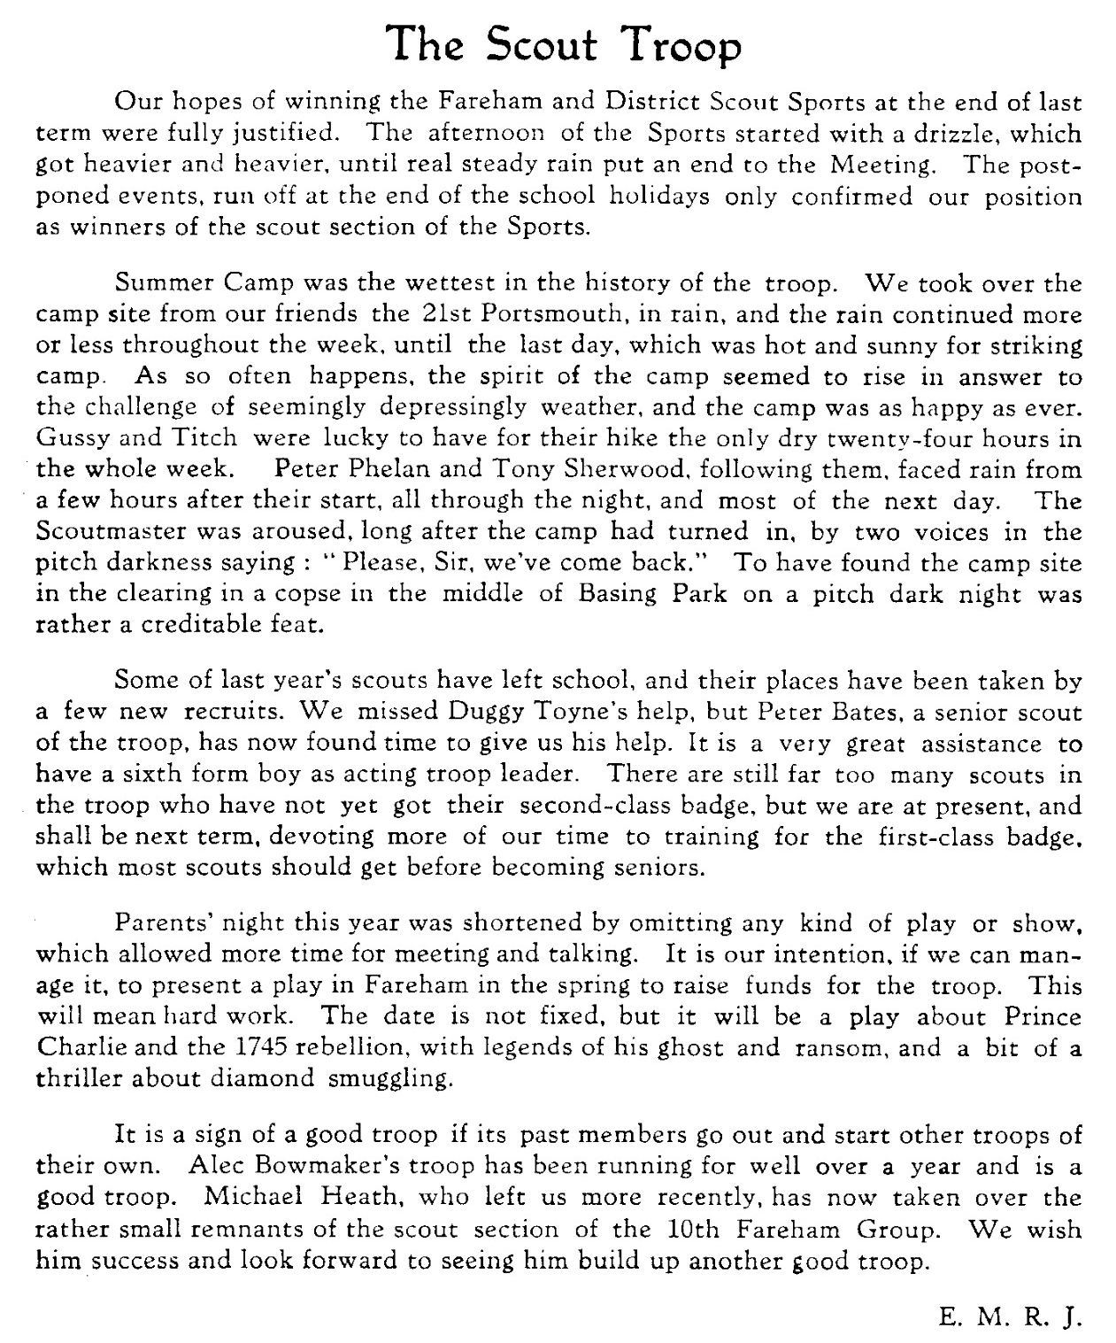
 | This the first time that Leader Revd Michael Royds Jones, has put his initials to any piece in the Lion Magazine. There are almost no photographs of the man, either. He was not a self-publicist.
Photo c/o Peter Phelan, on the left in this photo taken at the 1948 Camp at Privet
1949, May
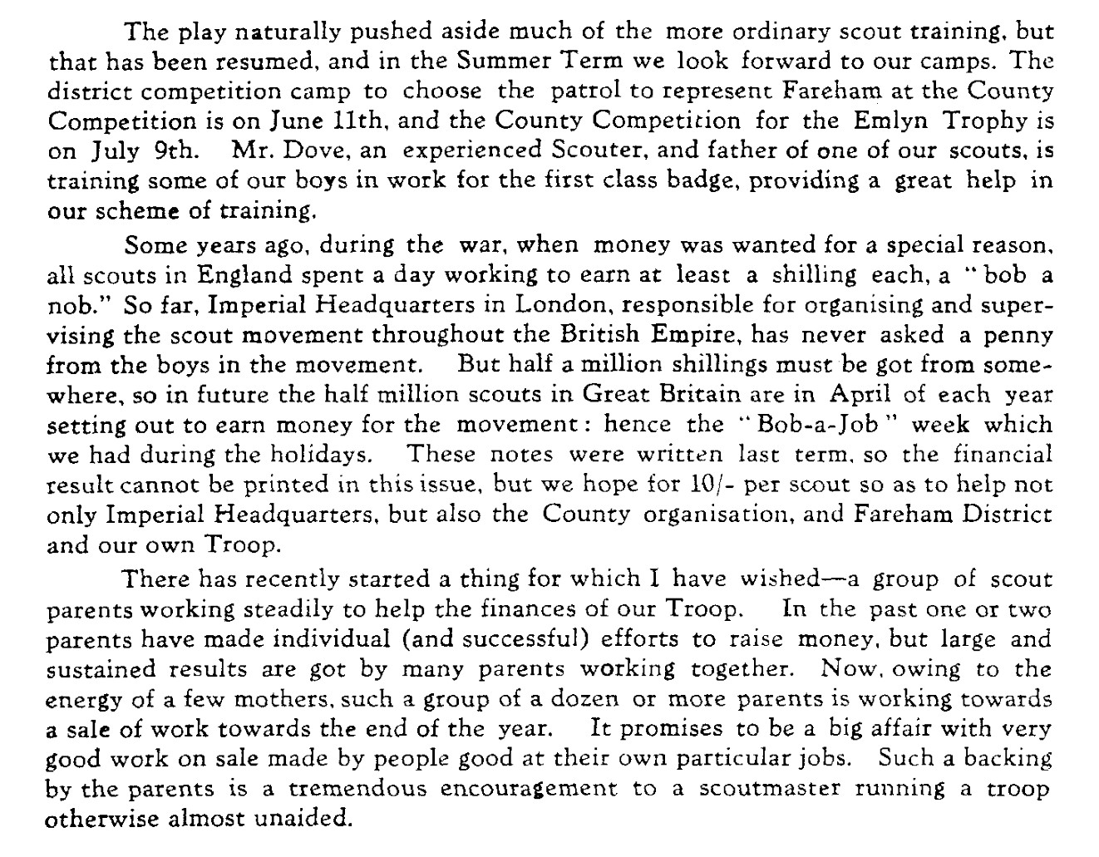
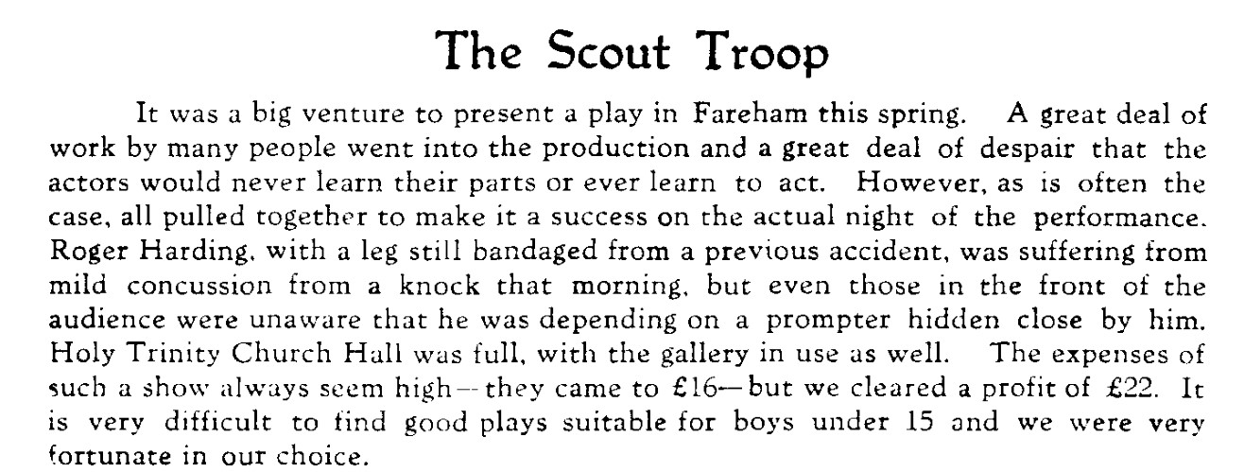

1949, August
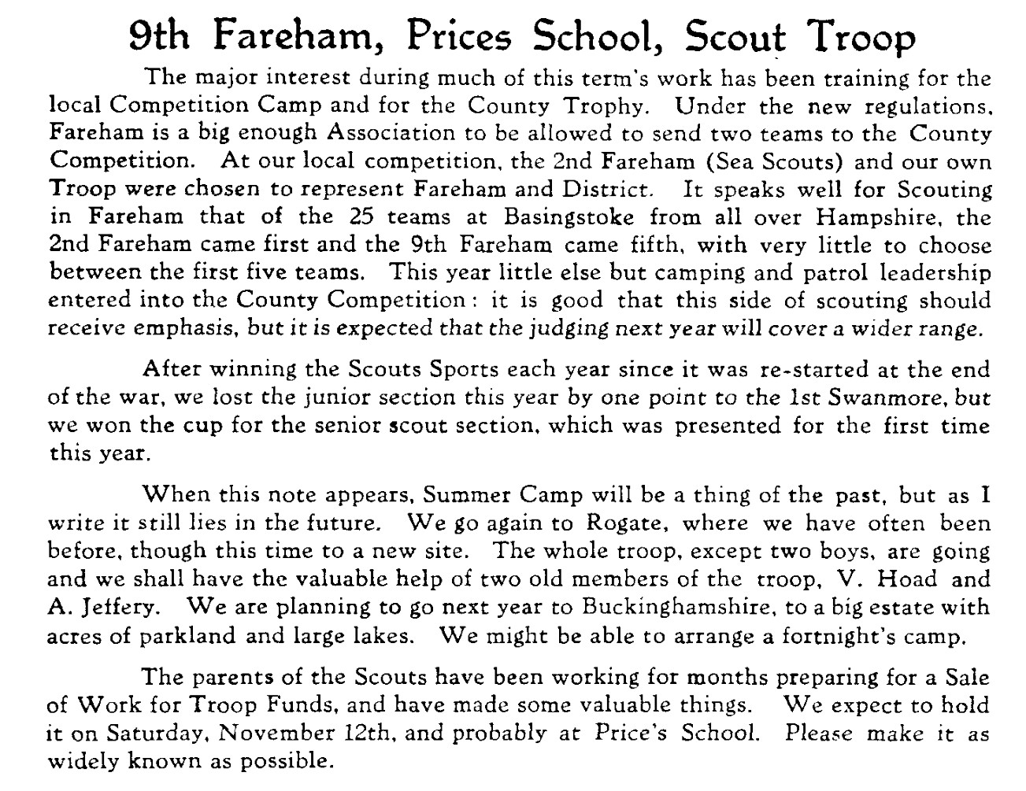

1950, January
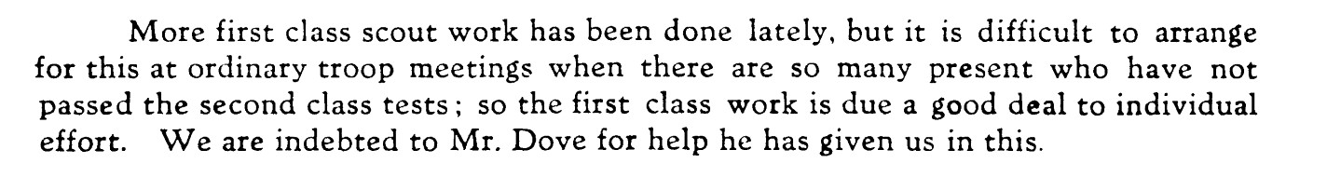
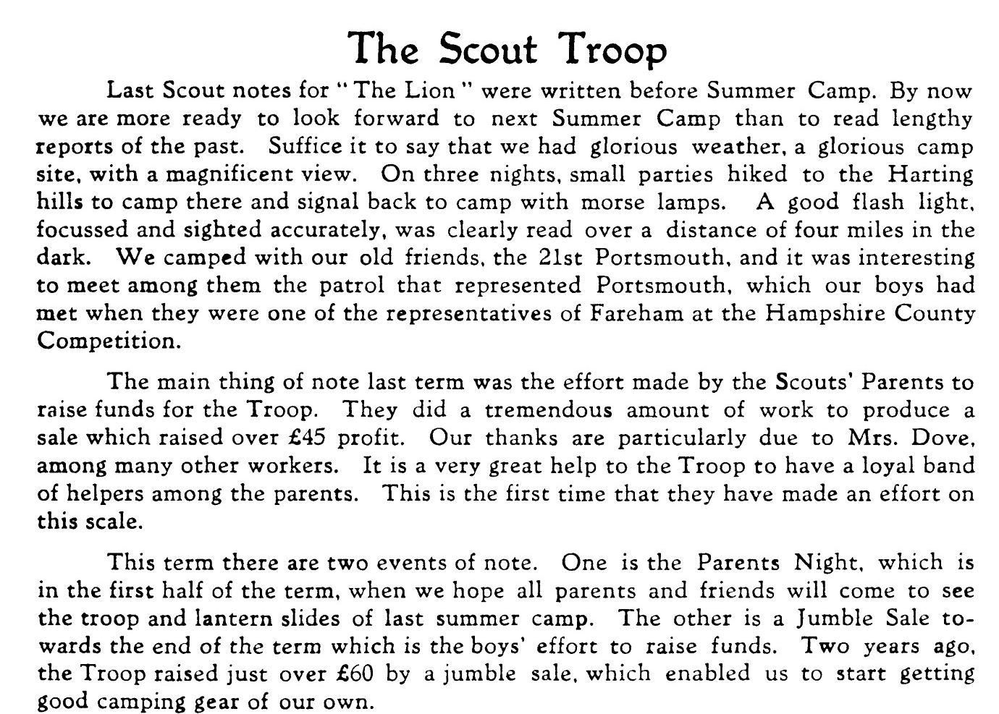

1950, April
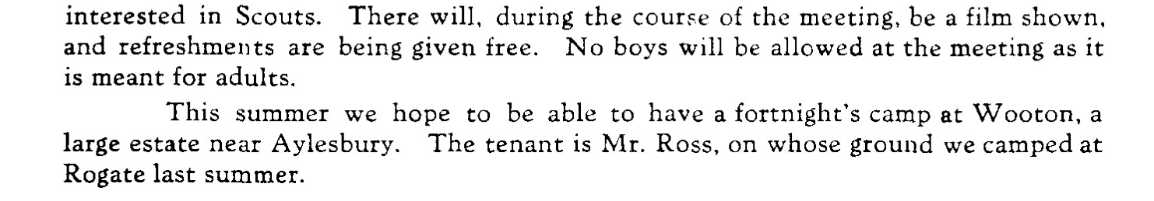
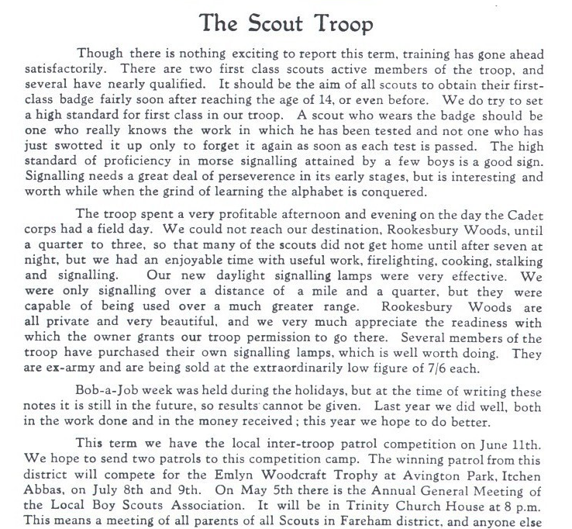

It is difficult to imagine, in 2020, the scale of work needed to bring a Camp venture to fruition in the 1940s. No mobile phones, not even many private or public phones. No Internet or emails, none of the Social Media of the early 2000s. Transport limitations. None of the modern tentage so easily accessible these days, or good, effective all-weather boots and clothing. Camping without easily accessible electric power points, or toilet conveniences. None of the easily erected pop-up tents, nor of lightweight pegging or weighing-down systems.
And, as means of entertaining teenage boys there were fewer distractions of the TV kind, with all of the modern “smart technologies”.
Commitment to an agreed arrangement could be generally relied-upon, with few social distractions or public entertainments. Society was not so “liberal” then, as now. Individuals were more inclined to corporate or group involvement, less selfish, accepting of challenges and personal limitations. Loyalty to a brand, such as a school, a team, or groups such as Scouts was common.
People were leaner, more vigorous, hardened to the rigours of life, less inclined to be a part of the blame culture.

1950, August
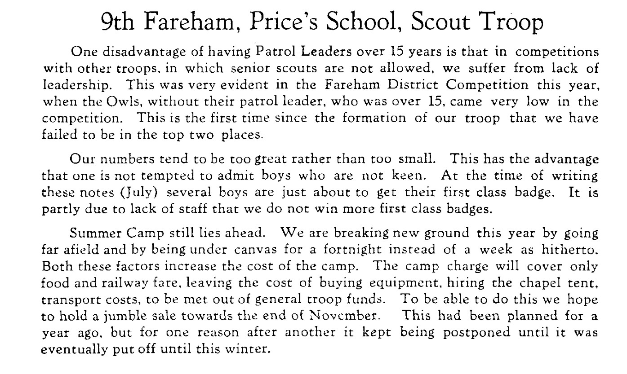

1951, July
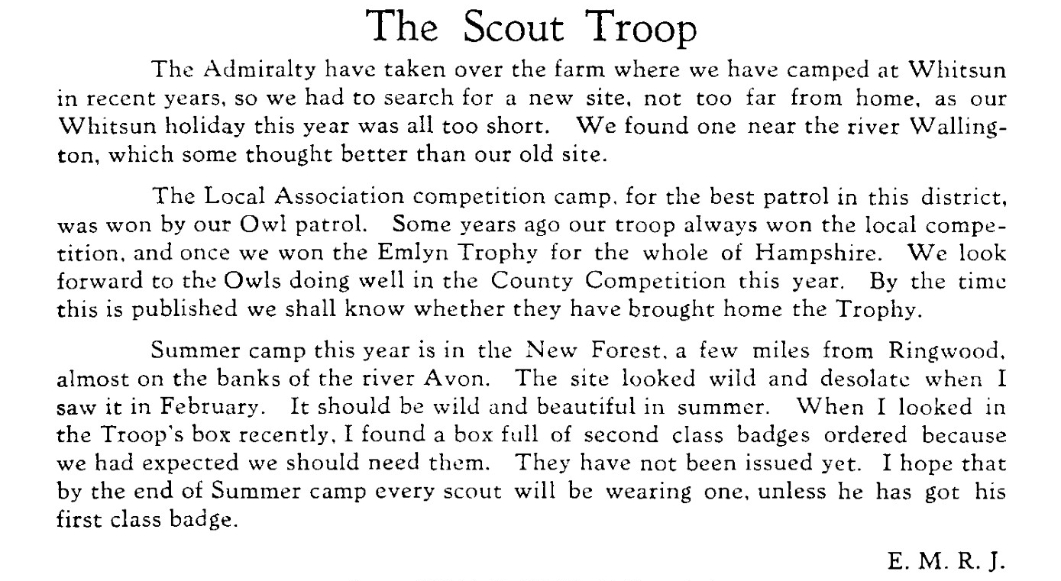

1952, January
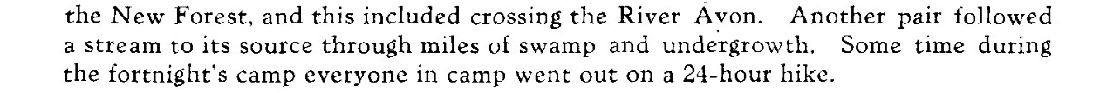
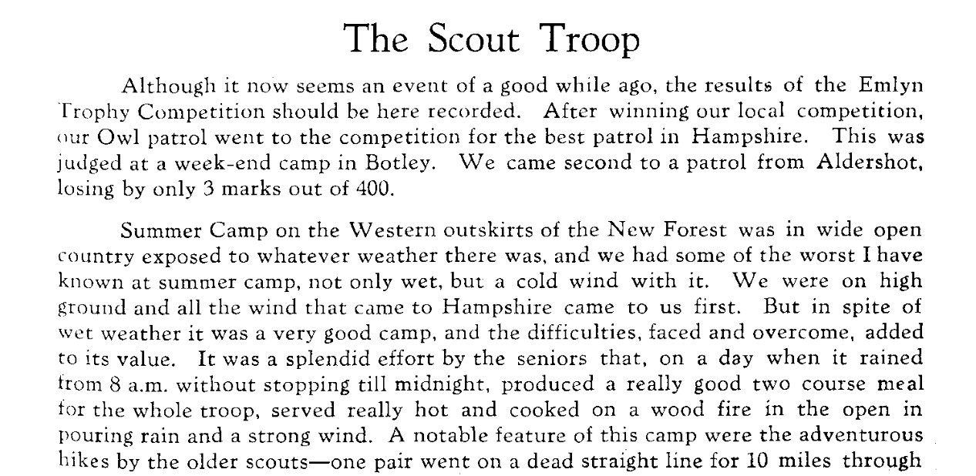

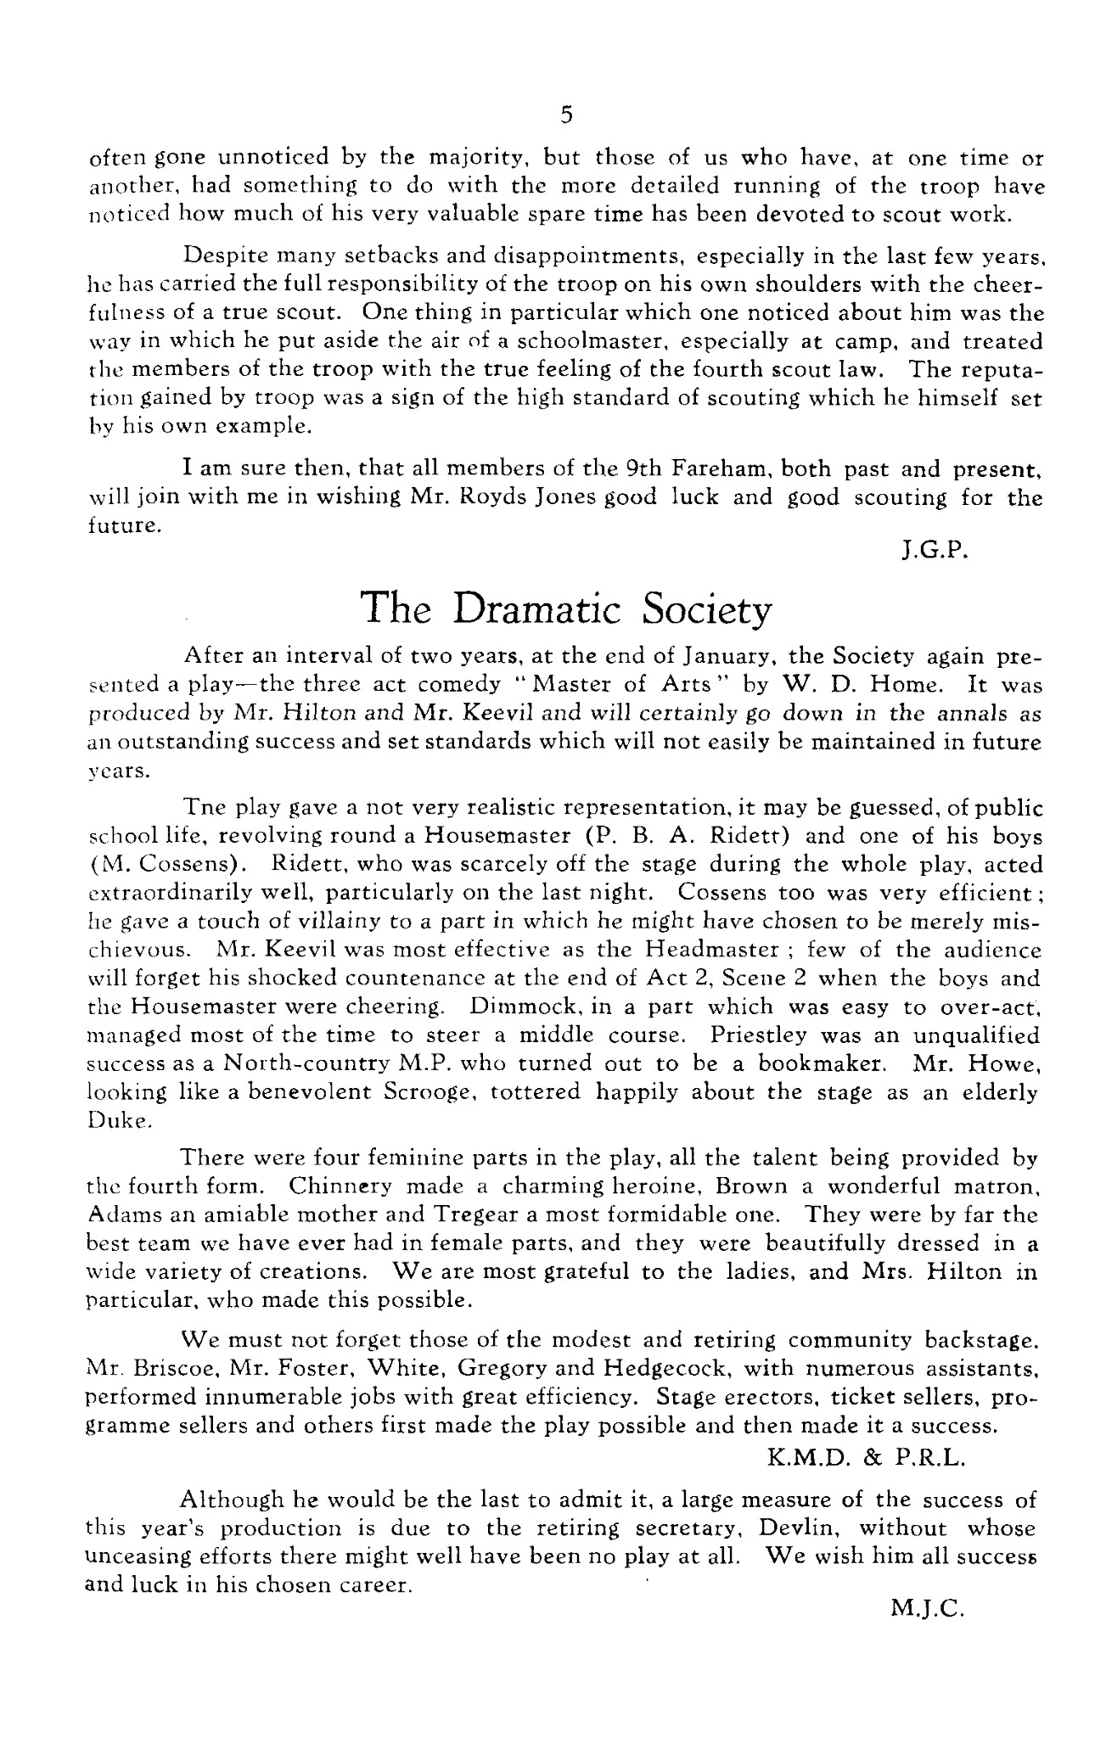
1952, May
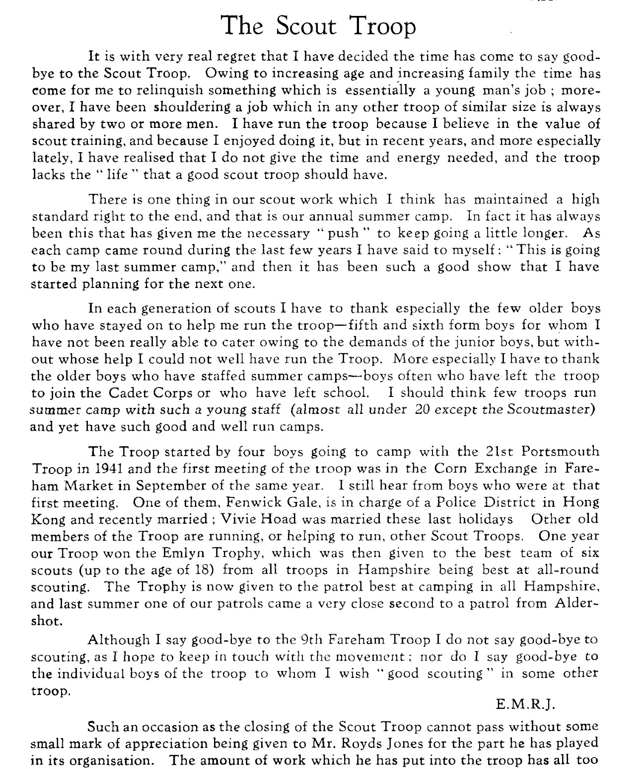

Lion: “One thing in particular which one noticed about him was the way in which he put aside the air of School master, especially at camp, and treated the members of the troop with the true feeling of the 4th Scout Law. The reputation gained by the Scout troop was a sign of the high standard of scouting which he himself set by his own example.”
Lion: “I suppose we were almost always on opposite sides in any argument that was likely to develop and so I could see clearly in him: his outstanding courage and absolute devotion to his beliefs. In an earlier age he might well have been a martyr himself and he would have expected his opponents to be equally resolute. He is a priest and a scientist but there must be many O.P.s who feel that they owe Royds a debt of gratitude, most of all for his devotion to scouting, camping or sailing.”
Herbert Thacker
Scout Camps
Year
1941 |  |  | 4 boys at a summer camp with Portsmouth Scouts formed the nucleus of Price’s Scouting
1942 | Whitsun | Wickham | Petrol leaders & Seconds
1942 |  | post exams | Senior Patrol weekend
1942 | Summer | Rogate woods | Whole troop, for a week.
1942 | Autumn | Boarhunt area | A Wide Game day with 2 other Troops
1943 | Summer | Rogate Woods | Whole troop, for a week.
1943 | Summer |  | 2 weeks farming Camp for 14+
1943 | Summer |  | Senior Pupils on “journeys” for 1st Class Test
1943 | Summer | New Forest | Patrol Leaders’ Conference
1944 | Whitsun |  | Weather almost too hot! Seniors follow Roman Road to Winchester & Salisbury – 3 days, carrying all kit: mishaps, abandoned.
1944 | June | North Boarhunt | “Lions” Competition Patrol won Local Assn. Scout Competition.
1944 | Summer |  | Whole TroopEdition No 5 of the Troop Magazine / Newsletter, appears
1945 | Whitsun | Wickham | “Campers’ Badge training for 2 boys on own.
1945 |  | Fareham & District Scout Rally revived. | Observation Tower & an aerial runway
1945 |  | Newtown | Weekend training camp for young, inexperienced team representing Fareham in Hampshire-wide Emlyn Cup Competition
1945 | Summer | Petersfield | No tents to hire or buy, none of own, so Bivouacs were the order of the day. Site almost perfect.
1945 | Autumn | Snowdonia | Mountain experiences. 5 boys + 2 Fareham 11th made up a Patrol to join 40 others.
1945 | Autumn | Wickham | 2 Patrol leaders camped-out
1945 | Autumn | Rookesbury Park | Annual Wide game with other local Patrols invited.
1946 | Summer | Beaudesert International Camp | Several European Countries represented
1947 | Spring | Spurlings Farm | Weekend camp to select team to represent Fareham in Emlyn Cup won by Price’s.
1947 | Whitsun |  | Senior Scouts (15+) competition
1947 | Summer | Rogate | Whole Troop.
1947 | Summer | Paris | 2 boys to be in group of 5 from Fareham to be in Hampshire Troop at the International Scout Jamboree. Others planning a long hike from Exeter to Fareham via Dartmoor and all hilly areas between!
1948 | Easter | Isle of Wight | 4 members planning a hike around the Island, carrying all kit.
1948 | Whitsun | Southwick Park | At WW2 D Day HQ
1948 | Summer | Scout chalet in Kandersteg, Switzerland | 2 Senior Scouts
1948 | Summer | Privet | Shared with Portsmouth Scout Troop
1948 | Summer | Sports competition | Won by Price’s Scouts
1949 | Spring |  | Produced a Play to raise funds. First “Bob-a-Job” week, for National Funds.
1949 | Summer |  | Won County Sports competition again.
1949 | Summer | Rogate | Camping again on familiar territory, helped by 2 past scouts. Good, new site, good weather.
1949 | Autumn |  | Successful fund-raising
1950 | Spring | Rookesbury Woods | Late afternoon & early evening signalling session.
1950 |  |  | Owl Patrol won the local Association competition camp, and will go forward to the Emlyn Trophy.
1951 | Summer | New Forest | Bad weather, adventurous hikes by seniors. Everyone on a 24 hour hike.
1952 | Revd Michael Royds Jones retires as leader of the  9th Fareham, Price’s School Troop.

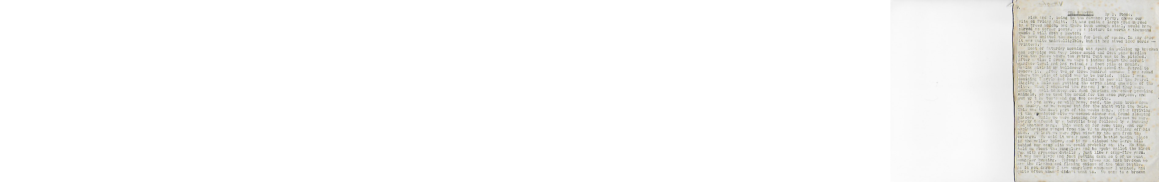

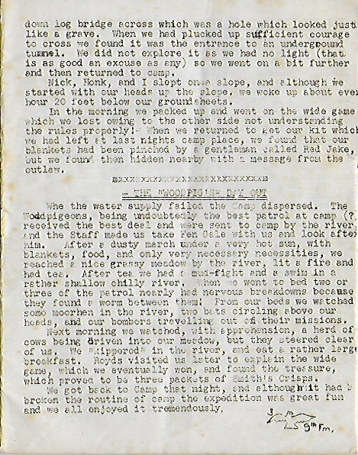

Review.
Ed: This, Price’s Scout Magazine No 5 original is in the possession of Old Pricean Victor Hughes, and was sent to me by Society President Patrick Nobes, then scanned and posted back to him on 29/05/2020,
At 28 pages long, it is a veritable marathon of typing by someone evidently committed-to and passionate about the Scouts, and in particular, the Price’s Scouts. It looks very much as if all of the typing has been done by the same person who has imparted a huge effort to generate a product of value to the writer and hopefully cherished by his Members.
Sadly, the existence of the Scouts and their activities, beyond Reports submitted to the Lion, probably by the leader Rev. E. Melville(Ted) Royds Jones, has warranted little commendation by higher authorities. That might not be correct, for all we have to go by is the printed word.
Mr. Royds Jones, aka “Wick” when I was at the School was a distinguished man, but completely self-effacing. Hardly a photo exists of him, nor any mention of his family. A dedicated and good teacher, who played a full part in the extra-curricular life of the School, the commitment he had to the scouts was total. To have funded such an expansive and outward and forward-looking group at the height of the ravages of the World War, was incredible. This was positivity on a grand scale. Grand, not because of its profile, but in quality terms, at a time when resources were lean, distractions to the war-time austerity were few, beyond the tragedies that affected all lives.
From such unpromising material emerged the Price’s Scouts, whose exploits are presented in the unedited Lion extracts gathered here. How sad then, that it’s role in the life of Price’s School went unheralded. No long-term memorial to its successes, and really, no great paper trail either. Contact has been opened with the Hampshire Scouts Headquarters in the quest for archive records, but nothing received to date.
The magazine appeals much to me for its home-spun crafting. It was produced with a passion, a love for what was being conveyed and those for whom it was written. I wonder what then, was thought of its purpose? Was it warmly welcomed, valued, cherished, appreciated by the boys as they aged, and their Parents? Whatever of its standing at the time, it is received here with value and admiration for its writer(s)
- The typescript is a big task
- There was so much to recount, and in such detail
- Layout is packed, with little white-space
- Attempts to use illustration were good and welcomed
- Reprographics uncertain, but likely quite primitive – war time concerns.
- Paper trimming used scissors on a handful of sheets at same time – leads to uneven cut lines as the paper slides
- Original paper is foxed
- Some hand-corrections, page numbers added post-printing
- The rough edges and other consequences of copying a document that has not been taken apart for the purpose have been left in to verify and authenticate the state of the original.
- The specimen see comes to me 76 years after its production and really, is in good condition.

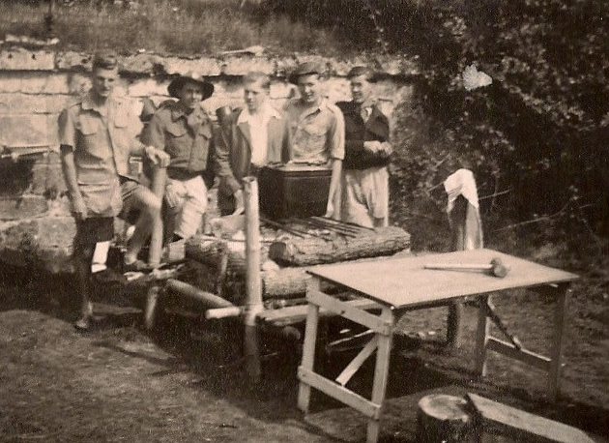
Picture c/o Peter Phelan. “This one was taken at summer camp in 1950 at Brill in Buckinghamshire. I can’t remember the name of the individual on the left. He was a stranger to me who had come to help. I don’t know whether or not he was an old boy of the school.
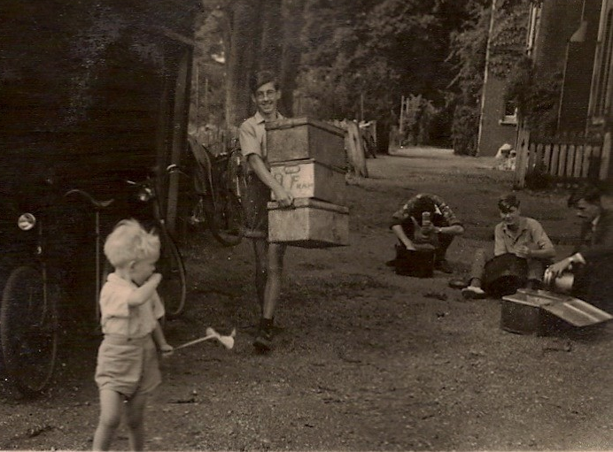
After him, from the left: “Titch” Stone, David Jones (who was a keen bell-ringer at St. Peter’s and St. Paul’s church), me and Tony Sherwood.”
Picture ↑c/o Peter Phelan: “Taken on the school premises. It shows some of us cleaning up after summer camp 1949 which was at Rogate. Tony Sherwood is carrying the boxes while I am the one in the middle scrubbing dixies. The hut on the left was formerly the school tuck shop (before my time) but then became the scouts’ store room. The little boy in front is Royds’s oldest son.
E.M.R-J might have felt the need to retire from the level of active scouting that had been much of his life in the 11 years of the 9th Fareham (Price’s School) Scout Troop but that sense of independence and self-reliance did not retire with him for, as is evident in the brief extract below, there was life in the remains of his legacy yet.

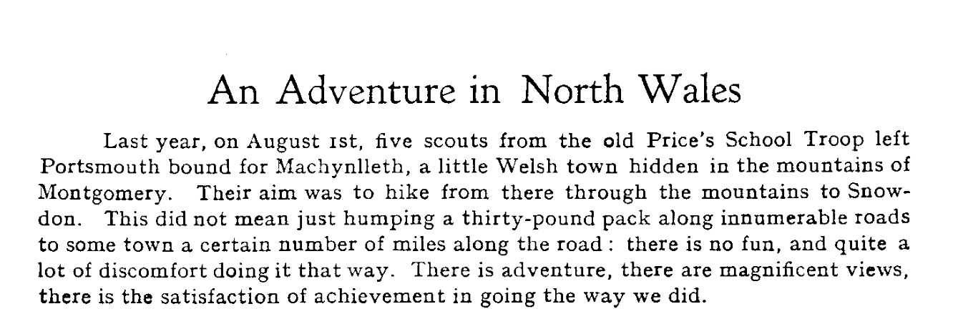

Ed: The pity of this “Adventure” was that there were no names attached to it in the relevant Lion, dated 1953, so no further listing can be made. The full article appears in the “Spirit of Adventure” section elsewhere in this Report. It was an Adventure of the toughest kind for boys of their age – about 15?
What a shame that the Price’s Scout Troop had closed before John Rousell’s time (1954 – 1959). And how proud of John would have been the founder and leader of that Troop, the Revd. E Melville Royds Jones on John’s Queen’s scout achievement, below.

Summarising the development of the Price’s Scouts:
Dec 1942 | Initial impetus was with a small group of 4 Price’s boys sharing a Camp with a Portsmouth Scout Troop. There was a struggle to find suitable premises for meetings, activities and storage. Wartime night time blackouts being an important consideration, resolved in the end by support from Home Guard personnel who helped with weekend activities. An early ambition was to build a trestle bridge rom blitzed trees! Thus much early activity was off-premises and engaging with the community.
Jul 1942 | Saturdays emerged as a good training time, and would have been a boon for the boarders too, giving them something to look forward to. The bridge was built over the Wallington stream. There were new recruits and a Troop flag was purchased. A Whitsun Camp for Patrol leaders and 2nds was already a kind-of future target that would be seen by patrol members as something to look up to. But the Camp at Wickham was a wet one! And another Camp after the Summer exams for the senior scouts’ Patrol, which tended to use Saturday evenings for training. The use of a Trek Cart was gained
Dec 1942 | Training continued for independence and self-reliance. I year on from foundation, 4 boys had grown to 4 Patrols with 26 scouts in all.a 5th Patrol, the Eagles was formed. Scouts enrolled as Home Guard Messengers. Morse Code and night time signalling lamp skills were developed.  “A privilege, in a world at war, to spend a carefree and happy Camp!”
Jul 1943 | 6 Patrols now, with 40 boys, but a small Hall and insufficient staff. Badges are an incentive to training, already differentiating according to experience. Future leaders emerging, with the First Class Scout badge. Using a barbed wire fence to transmit Morse messages! Learning to compromise. Service to the community being valued.
Dec 1943 | Good standard of camping praised. Independent camping etc, en route for 1st Class badges. A defined senior section now meeting on Saturdays. A new rank of Troop Leader introduced and a King’s Scout award earned. | Kings Scout Badge
Jul 1944 | Activities led increasingly by senior Scouts, with a Competition Patrol emerging preparing for the Emlyn Trophy inter Troop competition. Occasional “civilian” adult help at Camp, and the new, “Ninth” Troop magazine appears/
Mar 1945 | Loss of senior scouts to own Patrols becomes a problem for the younger groups Preparations for a parents’ Night. More testing times for senior scouts, and demanding Night Hike.
Jul 1945 | Two former scouts joined the Whitsun Camp. A return of the Fareham & District Scout Rally and a team in the County competition for the Emlyn Cup. New site fr the Summer Camp and with no tents, it bivouacs to keep us dry.
Dec 1945 | A good summer camp. Seniors off to N.Wales for some mountain experience. Continued support from past Scouts. 2nd class scouts meeting on a Wednesday night and seniors on Saturdays
Jul 1946 | Emlyn Trophy Winners while representing Fareham & District - team of 6 boys U17. Some adverse conditions for the Whitsun Camp. Public performances of P.E. to Music. Senior Scouts representing the County at the Beaudesert International Scout Camp in Leicestershire.
Mar 1947 | A successful Parents’ Evening was held, demonstrating a range of Scout activities, in the Green / Tin room. After the success of the International Camp last Summer, there were plane for a world-wide gathering in Paris – fund raising efforts throughout the area to support the few,, senior Scouts who might be able to attend.
Jul 1947 | The Price’s Troop will again represent Fareham in the Emlyn, County Competition. A new competition for Senior Scouts (15+) at Whitsun, and another (U15) later. Back to familiar Rogate for Summer Camp. Two Scouts at the International Jamboree in Paris.
Dec 1947 | Camp site shared with the friendly 21st Portsmouth Troop who lugged all the kit up the hill to pitch camp and occupy it for the first week, with us having the easier task of striking Camp and taking it all downhill, where we had an unfortunate 2 hour wait because the transport driver forgot to collect us!
Mar 1948 | A new venture – a Play to perform to parents on Parent’s Night.
Jul 1948 | Whitsun Camp in the grounds of Southwick Park where the D Day landings were planned. Lack of success in the Fareham area competition speaks of the need for thorough preparation and lack of complacency. Another benefit is that is induces enthusiasm in other Troops.
Dec 1948 | Back to winning the Fareham area competition. Shared campsite gain with the 21st Portsmouth Troop. No Play or Show at the Parents’ Evening – allowing more time for conversation. Mixed weather fortunes for those on their 1st Class Scout test hikes. Sixth Form, senior scouts helping the junior Patrols, and some assistance still from a former Troop member. Another now runs his own Troop.
May 1949 | It was all right on the night! Some additional help once normal training resumes. “Bob a Job” scheme starts, and a supportive group of Parents have an initiative to augment previous fund-raising .
Aug 1949 | A new senior scout trophy in the County Sports competition won by our Troop. Summer Camp will have two former Price’s boys helping.
Jan 1950 | Night exercises with flashlights at Summer Camp, shared again with 21st Portsmouth Troop. The Parents’ support group raised a good sum of money at a sale of work. More external help with Test preparation.
Apr 1950 | Just a routine term!
Aug 1950 | Summer Camp in a new destination, further away in the New Forest, and for two weeks!
Jul 1951 | Loss of access to Whitsun Camp site, new one at Wallington.
Jan 1952 | Owl Patrol, winners of the Fareham area Best Patrol competition and these were 2nd in the Hampshire-wide, Emlyn Trophy even, held over a weekend Camp at Botley. Some adventurous hikes by older scouts.
May 1952 | “The time has come,,,,”

9th Fareham (Price’s School) Scout Troop
An Overview
To have established an organisation like a Scout Troop was, for a single leader, a bold and considerate thing to have done. That its inception was at the heart of the War Time years in 1941, a doubly commendable thing to have done. Then add to that, the amazing successes that followed and the whole Price’s Scout story was a major achievement within the spectrum of attributes of which Price’s School could be proud.
The War years were generally ones of economic depression and social stasis. Personal, disposable funds were in short supply, but there was not much to buy, anyway. Combined costs of uniform, travel and other resources needed for scouting would have seemed an unwelcome intrusion to the family budget, thus acting in a kind of inhibitory way to membership and participation.
Troop funds were always low, but as the overall enterprise grew, on the back of a make-do-and-mend philosophy, initiatives surfaced that introduced a fund-raising trend extending over some years and enabled the purchase of some new tentage and other resources. “Bob a Job” week appeared on the scene in 1949 with the combined benefits of further funding of Troop and local Associations, as well as the start of a fixed levy heading in the direction of Scout H.Q. This was another addition to the breadth of activity emerging from the group.  Starting a new group that was to meet in the evenings, during war time led to some immediate difficulties in securing a venue that was Black-out competent – not the School. So, instantly the group was a part of the local community from amongst which came help from the local Civil | 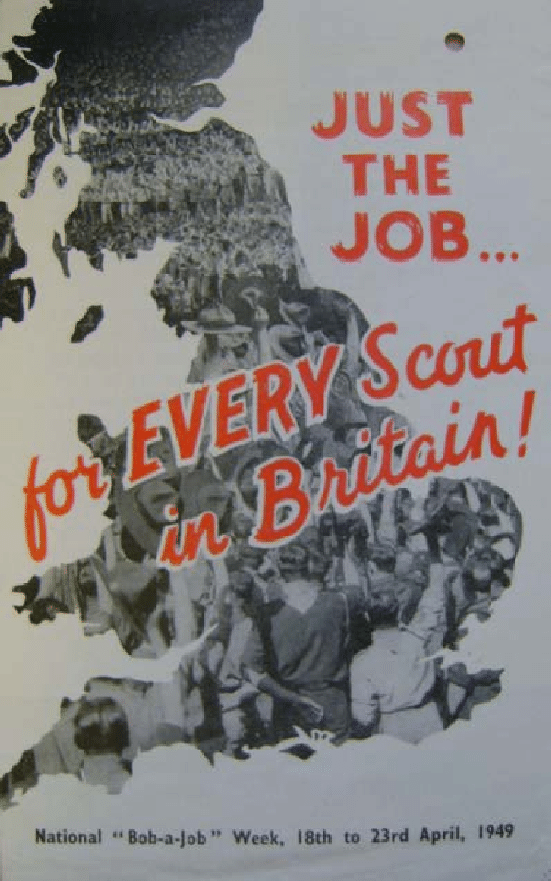
Defence unit to help solve its meeting needs. With a keen focus of training that related to the camping activity that is a constant thread throughout time, the Price’s Troop matured in interesting ways beyond the occasional fund-raiser. Diversifying the nature of the annual Parents’ evening with the inclusion of a Play illustrates two features that enabled the Troop to develop and sustain its unique character.
The initial idea for a Price’s School Troop arose from a group of 4 boys who went on a Summer Camp with scouts from the 21st Portsmouth group. This was to be a relationship that extended throughout the 11 year life of the Price’s Troop, with shared equipment set-up at a Summer camp by one Troop and taken down later at the end of the time using it at Camp, by the other Troop. It remains a good thing to have working co-operation with other groups.
Camping seems to have been the inner framework around which much of the training was directed. Routine troop meetings centred on Patrol-led learning sessions with practise Camps where the practical skills learned could be put into effect. That first level of teaching was by Patrol leaders, but there were tasks that older, 1st class Scouts would lead-on. Occasionally, there would be some external, Parent or Civil Defence led input, and, as a reflection of loyalty felt to the Troop, even past members would return to assist. One such person, even though at work, would cycle from Portsmouth on Saturday evenings to take sessions for the older Scouts. Training was thus inward-directed but outward looking, and well-supported with external help, differentiated according to experience and age. With a continuum of recruitment, progression, ‘graduation’ and return investment of effort, that is how successful groups become self-sustaining over time.
The Camps were immediately local, for practise purposes. There were Whitsun Camps not far away and Summer camps just over the horizon. Within the latter from time to time there were opportunities for small groups to take-off on their own for a night or two in pursuit of a given skill badge. The Camps were sometimes subject to external Inspection, and an amazing number of them seemed to be very wet! That just seemed to increase resolve however.
And from that sort of independence arose, at other times, a trend for ad hoc groups to decide all on their own to indulge in a Camp of their own, elsewhere. There is mention of days on the Isle of Wight, accounts of pairs of Cadets on Hikes to Scotland (late 1940s) and Reports featured in the “Spirit of Adventure” section of 5 boys spending several nights in Snowdonia (c. 1954), and others of pairs of boys in the series of Land’s End Races (1960s). None of these were adult organised or even supervised!
Scouting comes with its heritage of traditions and values and practices, some of which might seem quaint and old-fashioned these days – the latter maybe associated with the group structure rather than philosophy. I am sure that the Duke of Edinburgh Scheme, founded in 1956, has its basis in the Scouting model, though lacking in its on-going association with group organisation. That Scouting seems to have a fairly universal appeal is partly because it has remained consistent, yet able to adopt novel approaches. Its system of skill and service badges, hierarchically arranged represent meaningful challenges for even the long-term and senior Scouts, and the younger ones will always have an eye on what the bigger boys are doing. That applies too when there are interesting options available to the older boys which need a certain entry qualification as a pre-requisite for access.
Trekking into the unknown, wild-camping, reliance on skills previously learned all contribute to the growing and maturing person – what challenges, what incentives, what amazing chances to grow-into new phases of life!
There were domestic intra-Patrol competitions, local inter-Troop challenges, representational responsibilities and County Patrol Championships, County Sports events and even chances to be involved in 2 International Jamborees
That the initial group of 4 boys grew to 40, in 6 patrols with other occasional “specials” for competition and joint exercises, is testimony to the quality of leadership, the value of support from others and the panoply of chances made available by this excellent organisation.
The end came rather abruptly, it appears from the Lion termly Reports. But to the experienced eye, there were hints of its impending demise from the gradual, apparent loss of enthusiasm, and forward-planning.
Age, other demands on his life, not least his own family, the exhaustion of his own ideas and the realisation that this burgeoning enterprise really did need more and younger input made Royds make the most sensible though regrettable decision to close the Troop. Royds was a man generous with his time and sincere in his Christian outlook, always seeking the best for others, a good role model for the boys. Leaving behind him what, over 11 years he had nurtured so well, must have been an emotional time for him, especially as he continued to work in the School afterwards. I wonder what sort of a gesture of thanks and appreciation the Parents of the Price’s boys extended to him?
What a shame there was nobody willing or able to continue his great contribution to the lives of the boys who passed through his Troop, and to the School of which it was a part.
It is matter of great pity that until this Report was compiled, there was no permanent record of the achievement of the Revd. E. Michael (Ted) Royds-Jones in the conduct of his Scout Troop. Schools, organisations of any kind would do well to acknowledge the value of those working within them.
Further references to E.M.R-J are to be found in the Gazetteer, Parts 1 and 2, arranged alphabetically.
David Goldring 11/06/2020

Criticism! (In the Lion magazine of 1917)
In a different way of scheduling items for a publication such as this, one approach might have been to take a chronological sequencing, the better to show patterns of development. But, having come across the piece that follows which was printed in the July 1917 issue of the Lion, that inclination was culled in favour of a different approach, in the circumstances.
The Price’s Scout Troop was founded in 1941, 24 years after this article was published. The Troop was the concept of one man, with singular views about the kinds of influence that would serve well the needs of a growing lad. And that, set into the context of the nation at war, when really there was little to make childrens’ lives much fun or challenging or happy. The complete sequence of Reports in this Chapter gives the lie to the charges that find expression in the missive below. Quite what had stimulated such a vituperative and pompous assault on the Scout movement, who knows. There seems a bit of a macho influence at work here, and a hint at showing-off
There is no other mention of Scouting in Lion magazines until 1941, so perhaps a or some boy(s) were members of a local Troop outside of School with stronger attractions than a Cricket team practise.
Participation in the Cadet Corps in 1917 was not compulsory, neither was it universally welcomed. The CCF, of later date, the tradition of Steeplechase events, even the regularity of the “Hymn Sandwich” type School Assemblies each had their dissentient views and behaviours, showing rebellion against the established authority, so, “Observator” might just have been an “advanced party” reconnoitring the environment to assess potential for an alternative style of education. Surprising amongst all of this was that there were no follow-up articles. Perhaps it was an Editor’s attempt to stoke a fire? But more so, that it got printed in the first place. There is a nominal role as “Editor in Chief” for a Headmaster, to be able to quash such mal intent!)
Thereafter, peace reigned until the late 1920s / early 1930s when there was further dissent about what the Lion magazine might include, reported-on elsewhere, and how it should be arranged. Again, with some surprisingly public criticisms.

Jul 1917 Extract from School Notes by “Observator”!

We confess that we utterly fail to understand—it may be owing to lack of intellect and it may not—the particular brand of idiot that prefers to lead some little potty scout troop to being a member of the School Cadet Corps, and who whilst sporting his First XI colours, deliberately tries to cut a First XI. Match - with various net practices - in order to be present at the puerile sports held by an insignificant conglomeration of human protoplasm. We repeat that this brand of lunatic passes our comprehension. Do not mis-
take us. We have nothing to say against the Scout movement in general. There are Scouts, and Scouts. Malvolio might have said, “Some are born Scouts, some become Scouts, and some have Scouting thrust upon them.”
We should like to point out that there is nothing in the Scout system that is not learnt in a Cadet Corps, and at the same time with none of the gaudy display that characterises that movement. It, moreover, was not meant to run counter to the Cadet Corps. The majority of patrols are in those districts where either a Cadet Corps is an impossibility, or the schools of the district cannot raise one. So far, so good; but that anyone who has the chance of joining a Corps should prefer to be a little tin god among a bevy of atoms is a mystery.
Slackness, of course, is at the bottom of it. A Cadet Corps demands strict discipline, a Scout patrol does not to the same degree. It is free and easy, just about the worst thing for a school-boy. It is this brand of skunk who, while going about questioning the number of hours’ work put in by those who are doing National Service, takes precious care to do as little as he can. He rushes off to his satellites. They demand all his time.
We hope that the time is not far distant when the War Cabinet will compel every physically fit school-boy over 12 years of age to join his School Corps. It is quite time that these slackers were made to toe the line.
OBSERVATOR.
Ed: This, somewhat caustic attitude from a correspondent hiding behind a non de plume, suggests there was a Scouting alternative at the same time as the Cadet Corps, very near to the start of the 1908 School. But there is no other evidence of such a group in the School.

John Rowsell
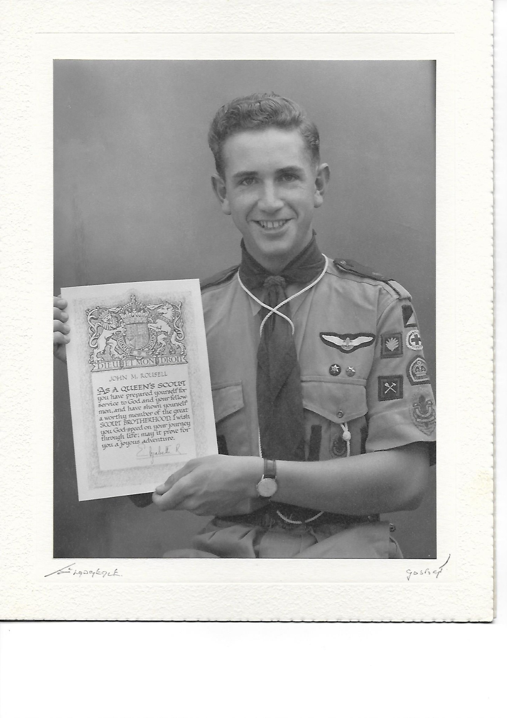
The only Pricean known to have achieved a King’s Scout badge.

Chapter sequence in the Lion Pride

Chapter No. | Title | Pages | File Size (KB)
1 | The Cultural Life of the School | 43 | 6630
2 | Introduction | 11 | 4030
3 | Boarding and up to 1949 | 44 | 21,285
4 | The Buildings | 47 | 136,380
5 | The 50s, 60s and 70s. | 56 | 7,236
6 | Extra-curricular Life of the School | 45 | 7,230
7 | The Charity School and the Family Price | 50 | 3,901
8 | The Cadet Force | 62 | 21,452
9 | Price’s Sixth Form College | 82 | 55,700
10 | The Major Sports: Football, Hockey and Cricket 1st XIs | 76 | 7,388
11 | Price’s Time Line | 13 | 1,492
12 | The Price’s (9th Fareham) Scout Troop | 65 | 57,545
13 | Minor Sports | 112 | 43,857
14 | The Library | 21 | 14,578
15 | Athletics and the Steeplechase | 26 | 3,769
16 | Spirit of Adventure | 45 | 19,214
17 | Academic Performance | 66 | 12,925
18 | The Lion Magazine and Other Publications | 46 | 12,925
19 | Price’s Creators | 142 | 30,009
20 | The Old Priceans | 76 | 17,703
21 | The Tercentenary Celebrations | 53 | 40,099
22 | Religion in the Life of the School. | 36 | 11,634
23 | A Portrait of William Price | 13 | 2,500
24 | Closing Thoughts | 11 | 23,214

